Forum: Economics and Social Council (ECOSOC)
Issue: Regulating cryptocurrency and digital currency in the global economy
Student Officer: Dora Yu
Position: Deputy President

Introduction
Cryptocurrency – decentralised, anonymous, free, convenient, and high returns – this brand-new concept has been flourishing ever since its introduction in Nakamoto’s paper in 2008; The Bitcoin launched twenty years ago at a trading price of $0.01, has grown nearly 1.08 billion percent in the past fifteen years to its current value of over $110,000. Nonetheless, even such an exciting technology, which seems to be nothing but wonderful, has its flaws – significant ones – that have yet to be fully addressed today. Delegates in this ECOSOC committee will create the first-ever (m)UN resolution concerning the topic of regulating cryptocurrency globally, exploring topics ranging from anti–money laundering policies to the next steps for “blockchain” technology.

Definition of Key Terms
Blockchain technology
Blockchain is an immutable and decentralized digital ledger database, recording blocks of encrypted content of cryptocurrency transactions. Each “block” has a unique hash as an identifier; all blocks are linked together, with each block including the hash of the previous block. The blockchain is stored on all participating computers, and each copy of the blockchain is updated with every new transaction, hence making it nearly impossible to alter the blockchain, ensuring the validity of recorded transactions.
Cold wallets
Cold wallets are devices that store private keys to cryptocurrency accounts offline. Such devices could be a USB device or a simple document storing the private key. Since cold wallets are not connected to the internet, it is immune to online hacking or online password leakage, and are only vulnerable to physical theft.
Hot wallets
Hot wallets are cryptocurrency accounts that are connected to the internet, temporarily storing the private key for convenience in sending and receiving cryptocurrency. Although the private key is still only accessible to the owner of the wallet, due to being connected to the internet, it is more vulnerable to hacks and theft than cold wallets.
Central Exchange
CEXs (short for Central Exchanges) are businesses that facilitate cryptocurrency trade between individual traders, overseeing transactions and matching buy and sell orders from users.
Stablecoin
Stablecoins are cryptocurrencies that match a fiat currency, like the USD, to maintain a relatively stable price.
Anti Money Laundering
AML (short for Anti Money Laundering) refers to laws and regulations in an attempt to uncover money from illicit income sources, such as human trafficking and drug trafficking. Money laundering is the process of concealing the origins of money from illegal sources.

Background Information
In the first appearance of the concept “cryptocurrency” and the invention of Bitcoin in Nakamoto’s paper in 2008, the concept revolved around a “free-market ideology” and a decentralized cash system, allowing convenient transactions globally among account holders with lower costs than traditional online bank transfer fees and less sophisticated procedures. While this new approach to currency brought proficiencies in account privacy, individual control over one’s assets, efficient transactions, also promoting innovations in blockchain technology, multiple cryptocurrency tragedies – TerraUSD's collapse in 2022, the $600 million Poly Network theft in 2021 - alerts necessary regulations urgently in need to ensure stability for both users/investors of cryptocurrency and economies involving its use.
Security risks, scams, and theft
Crypto cold wallets are almost entirely immune to online threats, as they are not connected to the internet, and are only threatened by physical theft of the device or losing/leaking the private key. On the other hand, crypto hot wallets, which are connected to the internet - often with CEXs (centralized exchanges) - can be vulnerable to security breaches or cyberattacks, requiring certain regulations to protect cryptocurrency accounts. Without global attention in preventing such risks, large-scale crypto crashes - such as the Terra LUNA crash in 2022 – may take place, resulting in hits on global economies tied to crypto networks. Especially for private sector CEXs, governmental regulations on transparency, currency liquidity, and cold wallet storage of user assets are necessary to avoid fraud by such companies, diminishing customer trust in crypto trading.
Exchange hacks
Exchanges are often attractive targets for hackers due to their large storage of cryptocurrency for liquidity. If the private key to hot wallets is stored on the exchange, it is then extremely vulnerable to an exchange hack. In 2018, one of Japan’s largest CEXs, Coincheck, was hacked $534 million worth of crypto assets in hot wallets. Since this incident, the Japanese government has introduced harsher regulations to domestic cryptocurrency CEXs, such as having to be registered with the government, demanding stricter risk management with AML and KYC requirements.
Fraud and theft
The risk of fraud is present for both cybercurrency CEXs and in individual transactions. In the example of FTX’s downfall, customer funds were secretly transferred to a second trading firm, Alameda Research, founded by the same founder, Sam Bankman-Fried (SBF). The secret transfers and fake balance sheets weren’t perceptible due to the lack of transparency and oversight, resulting in over $10 billion of customer funds being secretly transferred. Other examples of common cryptocurrency fraud include: fake wallet apps, where a user is fooled in thinking that the app allows them to use a digital wallet, then using the private key entered by the user to seal crypto assets in their account; Fake ICOs (initial coin offering), where the developer launch a new cryptocurrency merely with the name without supporting technology, vanishing with customer purchases without ever developing the coin.
Illicit activities
One key advantage of cryptocurrency is enhanced user privacy, where only the public key is needed to identify an account to transfer crypto assets, unlike traditional bank accounts, where one’s personal information must be bound to the account. However, the advantage of anonymous transactions also allows transactions for illicit activities (such as drug trafficking and money laundering) to be harder to trace. According to Chainanalysis, a value of $51.3 billion of cryptocurrency was received by illicit accounts in 2024 alone. One prominent method of addressing illicit transactions is blockchain forensics, which aims to trace transactions by analyzing transaction data and linking digital identities to provide legal enforcement. Key tools in blockchain forensics involve chain analysis – linking blockchain addresses to real-world entities and monitoring transactions in real time – ecliptics, identifying high-risk addresses and transactions – TRM labs, allowing government agencies to visualize blockchains to identify irregular patterns.
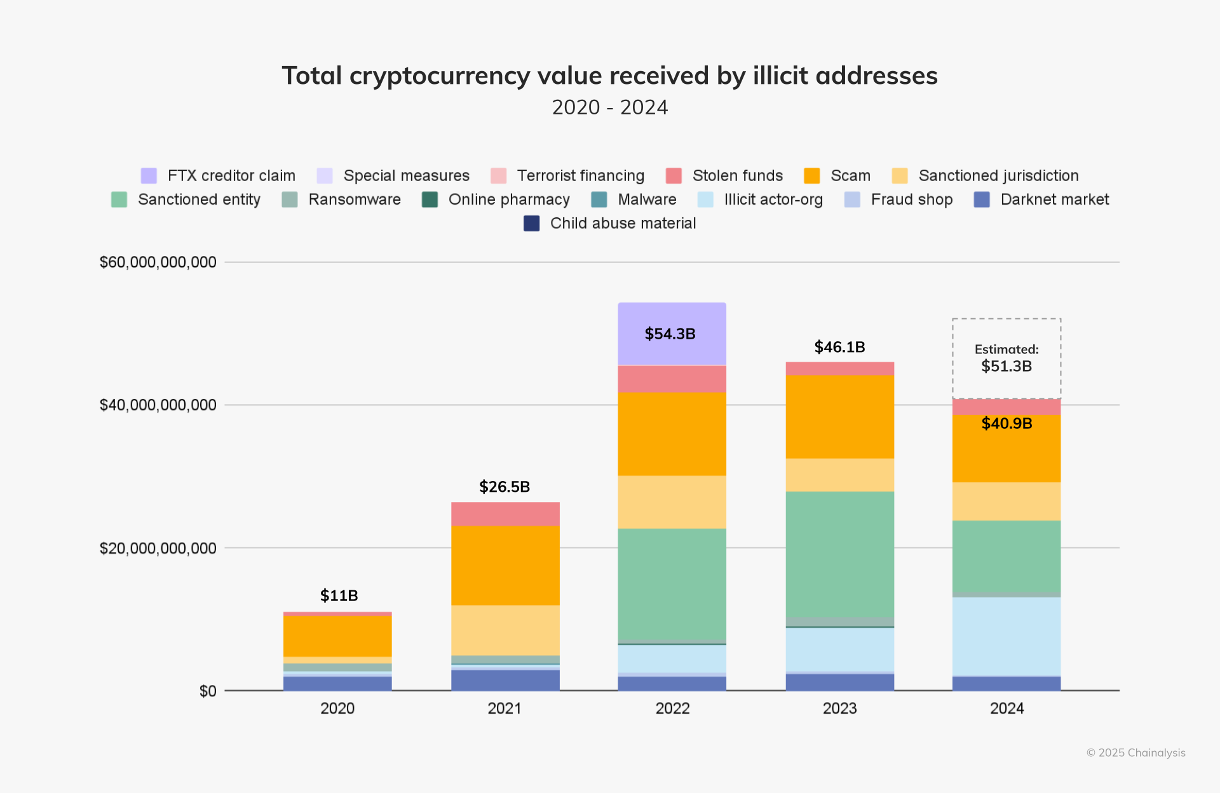

Caption #1: Graph of Total cryptocurrency balue received by illicit addresses (Chainanalysis)
Financial Stability
Certain types of stablecoins are beginning to be used as payment instruments in countries such as Vietnam and India, requiring stricter bank-like regulations in order to prevent monetary and financial instability. The IMF suggests the intervention of central banks in monitoring stablecoin issuers to ensure their liquidity, transparency, etc. Without stricter regulations or transparency, the use of cryptocurrency as a financial instrument may create financial risks in the economy due to its high volatility and price fluctuations. For example, the Japanese government put forth new regulations in 2024, demanding user crypto assets to be stored seperate from CESPs (Crypto asset exchange service providers) assets, and for CESPs to hold 95% of user crypto assets in cold wallets, with the remaining 5% in the CESPs own wallets as an additional buffer – regulations like such decreases chances of crypto asset hacking while boosting customer confidence in investing in cryptocurrency. It is important for consistent regulations internationally, since the crashing of one local cryptocurrency could result in global fluctuations. 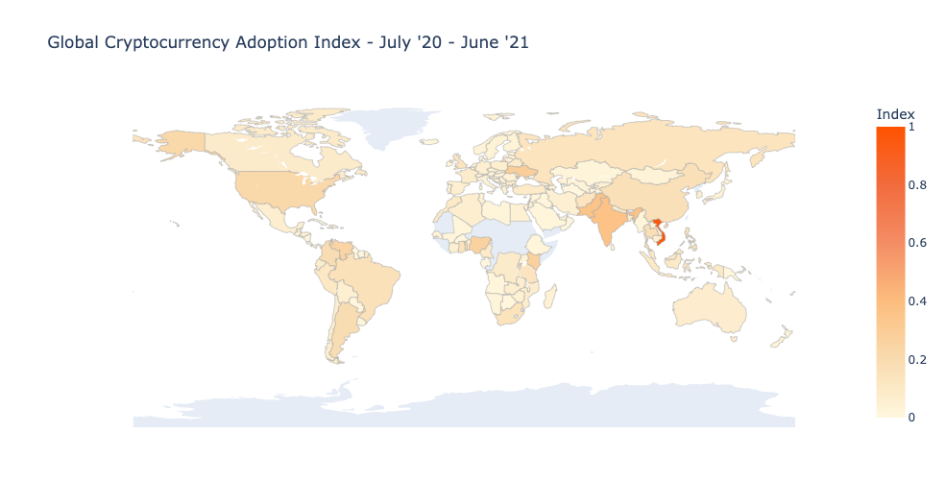

Caption #2: Diagram of Global cryptocurrency adoption index (Chainanalysis)
Blockchain innovation
Despite numerous areas of weakness in cryptocurrency in need of stricter regulations, certain nations remain unwilling to implement strict regulations to encourage continued innovation and development of blockchain technology, along with promoting the usage of bitcoin itself. An example is El Salvador, where a second layer of technology - “The Lightning Network” - is being developed and added to the existing blockchain technology for transactions to take place even quicker.
Environmental Impacts
Crypto mining, extraction, and other related activities require immense computational power, resulting in large carbon footprints and environmental impacts. According to the European Central Bank, popular crypto assets, such as bitcoin, consume energy equivalent to that of a mid-sized country per year. This is due to the complex blockchain technology, and the PoW (Proof – of - work) mechanism used for crypto mining, requiring lots of computational power and energy. Certain governments, such as Sweden and the EU, have proposed regulations around crypto activity carbon emissions (further addressed later in this report).

Major Countries and Organizations Involved
El Salvador
As one of the poorest countries in North America, with over 40% of the population below the poverty line, the introduction of Bitcoin in 2019 brought mass convenience along with low transaction fees, gaining much more popularity compared to traditional banking services, with less than 30% of the population participating. Not only was El Salvador the first nation to declare Bitcoin as a legal tender of compulsory acceptance, but the government also provided citizens with digital wallets, along with launching related educational programs for information. Despite the optimism within the government and increased development in blockchain technology, a report from El Salvador’s Chamber of Commerce and Industry saw only 14% of domestic businesses making transactions using Bitcoin.
United States
A unified regulatory framework yet to exist in the US, with different federal agencies treating cryptocurrency differently:

Securities and Exchange Commission
The SEC regulates cryptocurrency as securities, requiring all investment contracts to be formally registered, enforcing strict regulations through filing lawsuits against companies like Coinbase. Bitcoin and Ethereum ETFs were approved in 2024.
Commodity Futures Trading Commission
Different from the SEC, the CFTC regulates cryptocurrency as commodities supporting future contracts, taking enforcement actions against unregistered Bitcoin futures exchanges, taking conflicting stances with the SEC, and overlapping roles that are yet to be clarified by Congress.
Japan
Since the 2018 Coincheck CEX hack, the Japanese government has enhanced monitoring over crypto exchanges, requiring all such companies to be registered with the Financial Services Agency (FSA), while complying with AML regulations. In 2020, Japan established the Japanese Virtual Currency Exchange Association (JVCEA) - with all crypto exchanges as members – as a self-regulatory organization, evaluating reports of new cryptocurrencies, while also establishing “Rules for Selling New Crypto Assets” as requirements for all ICOs.
European Union
The EU has an overall optimistic attitude towards crypto-assets: the regulation on markets in crypto-assets (MiCA) was approved by the Council in 2023, covering three types of crypto-assets: asset-referenced tokens (a type of stablecoin referencing multiple assets), which are legally recognized as a form of payment and used as a store of value; e-money tokens - referencing only one type of asset – intended as a means of payment; and others as utility coins. All crypto-asset issuers must be authorized to operate in the EU, following rules requiring supervision and authorized transactions, transparency, and disclosure of environmental impacts.
International Monetary Fund
In early 2023, the IMF presented papers to the G20 with the following key policy recommendations: the cruciality of “transparent, consistent, and coherent” monetary policy frameworks to maintain dominance of sovereign currencies; protecting national sovereignty in avoiding granting legal tender status for cryptocurrencies; addressing crypto-asset volatility; and having specific, unambiguous tax regulations. While suggesting strong alignment to domestic frameworks such as AML, more importantly, the IMF points to the importance of international cooperation given the “borderless nature of crypto assets".
Financial Action Task Force
The FATF was founded in 1989 to set global standards for issues such as AML, Countering Financing of terrorism (CFT), regulation, and transparency of virtual assets. Member states of the FATF have a strong tendency to follow the organization’s guidelines to avoid being placed on the “Grey List” or “Black List”, which may result in sanctions for such nations that don’t comply.

Timeline of Events
Date | Description of event
2008 Oct | Bitcoin was first invented with a published cryptocurrency white paper by Satoshi Nakamoto,  Blockchain technology for financial security first introduced
2009 Jan 9th | Bitcoin officially launched
2011 | First Altcoins launched
2012 | Coinbase, the first American cryptocurrency exchange was founded
2014 Feb | Mt. Gox exchange collapses after losing 850,000 BTC
2015 July | Ethereum launches
2017 | China bans ICOs  Japan recognizes bitcoin as legal tender
2018 | SEC begins investigating unregistered ICOs
2021 | El Salvador recognizes bitcoin as legal tender  China officially bans all crypto trading and mining
2022 May | Terra-LUNA collapses from attack on liquidity pool, wiping out $45 billion in under one week  FTX collapses after a spike in customer withdrawal
2023 | SEC begin filing lawsuits against Coinbase  EU passes MiCA regulation, the first comprehensive cryptocurrency regulation

Relevant UN Treaties and Events
To this date, there has yet to be a finalised UN resolution regarding cryptocurrency regulation.
However, in the Ad Hoc committee established under the UNGA Resolution 74/247 (2019), “United Nations Convention on Countering the Use of Information and Communications Technologies for Criminal Purposes” was drafted on 29 June 2021 (link seen in appendix section). Although this draft resolution was focused on cybercriminal activities as a whole rather than specifically on AML or other illicit uses of cryptocurrency, this draft is nonetheless an introductory and exploratory resolution to this yet-unaddressed issue.

Possible Solutions
Considering the absence of significant ongoing UN actions/dialogue regarding the topic of cryptocurrency, delegates will hopefully explore a myriad of possible solutions to address this topic effectively on a global scale. Below are a few possible considerations:
Global Collaboration Framework
As the IMF suggests, cryptocurrency is a borderless technology and can only be fully addressed with global collaboration. A possible solution would be the creation of a new organization comprised of all member states in the interest of cryptocurrency development. Another method with similar results would be to expand FTAF membership, allowing more nations to join in the conversation on negotiating cryptocurrency regulations. However, delegates need to further consider differences in interest, development level, and financial capability of member states taking part in the conversation, and how to effectively address such differences in global frameworks.
Consumer and Invester protection
Other than illicit activities and fraud deterred with stricter regulations, another aspect of the solution lies in directly educating individual traders to spot and report illicit transactions and fraud activity around them. Possible methods could be through educational campaigns, disclosing risks of cryptocurrency investment, or forming stricter transparency policies while monitoring crypto exchange platforms to protect individuals and companies investing.
Enforcements against AML and terrorist financing
By enforcing AML/KYC regulations for wallets and CEXs, illicit transactions may be easier to spot and trace. Such enforcements could also perform more effectively if coupled with increased dialogue and collaboration between regulators and crypto companies, both domestically and internationally. However, delegates need to evaluate and explore the balance between maintaining user privacy and AML/KYC enforcements in the global dialogue, as cryptocurrency’s greatest disadvantage is at the same time one of its greatest advantages compared to traditional bank transfers – anonymity.
Regulatory Sandboxes
Cryptocurrency regulatory sandboxes allow regulations, or cryptocurrency launches, to be simulated in an isolated testing environment of all regulated agencies and companies in the industry before being officially launched. Spain, the EU, and the US have created regulatory sandboxes and promoted their use in the crypto community. While different sandboxes have targeted testing environments for cyber-attacks, system hacking, etc., limitations are present in the difficulty of setting timeframes for achieving certain testing goals. Most importantly, current sandboxes only cover national testing environments and have yet to exist internationally.

Bibliography
“Blockchain & Cryptocurrency Laws & Regulations 2025 | Japan.” GLI, 19 Apr. 2024, www.globallegalinsights.com/practice-areas/blockchain-cryptocurrency-laws-and-regulations/japan/. Accessed 7 July 2025.
“Britannica Money.” Britannica.com, 4 July 2025, www.britannica.com/money/cryptocurrency-regulation. Accessed 7 July 2025.
“Britannica Money.” Britannica.com, 4 July 2025, www.britannica.com/money/cryptocurrency-regulation. Accessed 7 July 2025.
“Britannica Money.” Britannica.com, 5 July 2025, www.britannica.com/money/cryptocurrency-scams. Accessed 7 July 2025.
“Britannica Money.” Britannica.com, 7 July 2025, www.britannica.com/money/what-is-blockchain. Accessed 7 July 2025.
CFI team. “What Happened to Terra?” Corporate Finance Institute, corporatefinanceinstitute.com/resources/cryptocurrency/what-happened-to-terra/.
Cooper, Daniel. Strike Mission: El Salvador, Blockchain Technology, and Sustainable Development.
“Crypto Needs Comprehensive Policies to Protect Economies and Investors.” IMF, 18 July 2023, www.imf.org/en/Blogs/Articles/2023/07/18/crypto-needs-comprehensive-policies-to-protect-economies-and-investors. Accessed 7 July 2025.
“Crypto-Assets: How the EU Is Regulating Markets.” Consilium, 2023, www.consilium.europa.eu/en/policies/crypto-assets-how-the-eu-is-regulating-markets/. Accessed 7 July 2025.
George, Kevin. “Cryptocurrency Regulations around the World.” Investopedia, 2021, www.investopedia.com/cryptocurrency-regulations-around-the-world-5202122. Accessed 7 July 2025.
Gschossmann, Isabella, et al. “Mining the Environment – Is Climate Risk Priced into Crypto-Assets?” European Central Bank, no. 18, 11 July 2022,
www.ecb.europa.eu/press/financial-stability-publications/macroprudential-bulletin/html/ecb.mpbu202207_3~d9614ea8e6.en.html, https://doi.org/xx.xxxx/xxxxxx. Accessed 30 July 2025.
https://www.facebook.com/Investopedia. “Cold Storage: What It Is, How It Works, Theft Protection.” Investopedia, 2017, www.investopedia.com/terms/c/cold-storage.asp. Accessed 7 July 2025.
“Crypto Regulatory Sandbox: What It Is, How It Works.” Investopedia, 2018, www.investopedia.com/terms/c/crypto-regulatory-sandbox.asp#toc-limitations-of-crypto-regulatory-sandboxes. Accessed 26 July 2025.
jamesju. “Cryptocurrency Laws and Regulations.” Thomson Reuters Law Blog, 21 Mar. 2025, legal.thomsonreuters.com/blog/cryptocurrency-laws/#what-is-cryptocurrency-regulation. Accessed 7 July 2025.
News, BBC. “Coincheck: World’s Biggest Ever Digital Currency “Theft.”” Bbc.com, BBC News, 27 Jan. 2018, www.bbc.com/news/world-asia-42845505. Accessed 7 July 2025.
Reiff, Nathan. “Can Crypto Be Hacked?” Investopedia, 2015, www.investopedia.com/articles/investing/032615/can-bitcoin-be-hacked.asp. Accessed 7 July 2025.
Reuters. “Japan to Give Crypto Assets Legal Status as Financial Products, Nikkei Says.” Reuters, 30 Mar. 2025, www.reuters.com/technology/japan-give-crypto-assets-legal-status-financial-products-nikkei-says-2025-03-30/. Accessed 7 July 2025.
Saito, So, and Kazuki Imanari. “Crypto Regulations in Japan 2024.” Lexology, So & Sato Innovative Lawyers, 3 Sept. 2024, www.lexology.com/library/detail.aspx?g=1d7e4131-9a61-43d8-8c2c-158b5452976e&utm_source=chatgpt.com. Accessed 26 July 2025.
“Some Key Elements of Crypto Regulation.” IMF, 9 Dec. 2022, www.imf.org/en/News/Articles/2022/12/16/sp120922-some-key-elements-of-crypto-regulation. Accessed 7 July 2025.
Suberg, William. “Japan Hits 6 More Crypto Exchanges with “Business Improvement Orders.”” Cointelegraph, 22 June 2018, cointelegraph.com/news/japan-hits-6-more-crypto-exchanges-with-business-improvement-orders. Accessed 7 July 2025.
Team, CFI. “Stablecoin.” Corporate Finance Institute, 21 Nov. 2023, corporatefinanceinstitute.com/resources/cryptocurrency/stablecoin/. Accessed 7 July 2025.
Team, Chainalysis. “2025 Crypto Crime Trends from Chainalysis.” Chainalysis, 15 Jan. 2025, www.chainalysis.com/blog/2025-crypto-crime-report-introduction/. Accessed 7 July 2025.
“Global Crypto Adoption up 880% in 2021 - Chainalysis.” Chainalysis, 14 Oct. 2021, www.chainalysis.com/blog/2021-global-crypto-adoption-index/. Accessed 7 July 2025.
Vern. “Japan’s History of Crypto Asset Regulation: 2014-2020 - Sygna.” Sygna, 28 May 2020, www.sygna.io/blog/japan-crypto-regulation-history-2014-2020/. Accessed 7 July 2025.
Walla, Katherine. “How to Prevent the next FTX.” Atlantic Council, 17 Nov. 2022, www.atlanticcouncil.org/blogs/new-atlanticist/how-to-prevent-the-next-ftx/. Accessed 7 July 2025.
Chainalysis.com, 2025, www.chainalysis.com/wp-content/uploads/2025/01/image1.png. Accessed 7 July 2025.

Appendices
- https://sdgs.un.org/sites/default/files/2022-05/2.1.2-32-Cooper%20-%20Strike%20Mission%20Elsalvador%20Blockchain.pdf
- https://www.unodc.org/documents/Cybercrime/AdHocCommittee/Comments/RF_28_July_2021_-_E.pdf
- https://www.atlanticcouncil.org/blogs/new-atlanticist/how-to-prevent-the-next-ftx/
- https://www.atlanticcouncil.org/blogs/econographics/three-challenges-in-cryptocurrency-regulation/
- https://legal.thomsonreuters.com/blog/cryptocurrency-laws/#what-is-cryptocurrency-regulation

