Forum: Environmental Commission (ENV)
Issue: Measures to address the waste generation from fast fashion industries
Student Officer: Sarah Kim
Position: President

Introduction
Fashion is a serious business with its global industry’s worth being estimated to be around $1.7 trillion in 2023. With fashion being one of the most crucial parts of people’s lives, we must recognize how fast the trends that people pursue change, especially in the context of fashion. Fashion trends are evolving at an unprecedented pace, and they are heavily driven by developments in social media, technology, and many other factors. Social media platforms such as TikTok, Instagram, and YouTube play a crucial role in accelerating fashion trends. For example, on TikTok, wearing pajama pants as streetwear was popularized with over 9600 posts with the hashtag #PajamaPants. However, as new trends are continuously emerging, the old, or not even considered as old, trends are declining at the same pace, and they are driving fashion industries to come up with new products more quickly than ever. This rapid production and distribution of clothing products is generally referred to fast fashion industry.
Fast fashion has significantly transformed the global fashion industry by making the latest trends available to consumers quickly. The number of garments produced per year has nearly doubled over the past 20 years, and the global consumption of fashion has increased by 400%, reflecting the rapidly changing fashion trends and an increase in fast fashion industries. This kind of industry thrives on overproduction and overconsumption, which encourages consumers to buy more products and discard them quickly as trends shift. This characteristic of the fast fashion industry, as a result, raises several concerns. These concerns not only include general concerns regarding worker exploitation and unsafe working conditions but also encompass environmental impacts such as greenhouse gas emissions and water pollution.
One of the most crucial environmental impacts we must focus on is the massive waste generation from the fashion industry. Despite the fact that there is more consumption occurring, the average lifespan of a fashion product is decreasing more as shifting of trends becomes faster and faster, generating a huge amount of textile waste as a result. Around the globe, 90 million tonnes of textile waste are being generated every year, and approximately 85% of it ends up in landfills each year, where synthesized materials take up to hundreds of years to decompose and release toxic chemicals into the soil. Unrecyclable items end up being incinerated, which also releases harmful pollutants, exacerbating environmental impacts.
The fast fashion industry’s rapid rise has now become a significant and crucial cause of environmental concerns. These environmental impacts are present at every stage of the garment’s lifecycle, from production to disposal. Addressing these issues is thus crucial to improving our environment and will require changes in production practices, consumers’ behaviors, and policy frameworks in order to create a more sustainable and circular fashion industry.

Definition of Key Terms
Fast fashion
Fast fashion refers to cheaply produced and low-priced garments that copy the recent changes in styles and are quickly distributed and marketed to the public to follow recent trends and update products according to the trends. This allows retailers to provide a huge number of fashion items with more variety at a low price. Granted, fast fashion’s value in retailers must not overlook the environmental impacts, especially the waste generations, it generates.
Fast fashion retailer
A fast fashion retailer is a company or store that rapidly produces recently designed and low-priced clothing by compressing production cycles and producing up-to-date designs, which enables consumers to cheaply follow the fast fashion trends. These kinds of companies are now becoming major online or offline marketplaces for consumers looking for refreshing designs that they can easily afford.
Textile waste
Textile waste refers to any discarded materials made from natural or synthetic fibers that are no longer needed, including items with different textile materials, such as old or damaged clothes, footwear, sheets, and carpets, that are often generated from manufacturing offcuts, excessive stocks, and commercial textiles.
Overproduction
Overproduction is the condition in which the amount of goods produced exceeds the demand. It often results in surplus inventory, price drops, and potentially unsold goods. It also directly increases waste generation as it uses unnecessary materials and resources to produce goods that are more than needed.
Overconsumption
Overconsumption refers to excessive consumption of goods that are more than what is needed. Just as overproduction, overconsumption also leads to environmental degradation and increased waste generation.
Short lifespan
Lifespan of a fashion product refers to the time interval between when a product is sold and when it is discarded. Products that are replicated from recent runway styles or produced only to follow the fast-changing fashion trends have a much shorter lifespan than basic products that do not quickly become obsolete.
Landfilling
Landfilling is a process of disposing of materials by burying them in designated areas. Textile wastes generated from fast fashion industries often end up in landfills; however, since many of them are made of synthetic and non-biodegradable materials, they persist in landfills for hundreds of years, releasing toxic chemicals as they slowly decompose, emitting greenhouse gases, and contaminating soils and underground water.
Incineration
Incineration is a process of disposing of materials by burning them at high temperatures. This method reduces the volume of solid wastes by up to 90% by converting it to ash or flue gas. It is used when landfills reach their capacity for waste generated and when the waste is not suitable for recycling. This method, however, releases toxic pollutants and greenhouse gases, contributing to an increase in serious environmental issues.

Background Information
Over the past few years, the fast fashion industry has only grown, reaching $184.94 billion in 2025 globally, which has grown by 10.74% from 2024 and is further estimated to reach $291.1 billion by 2032.
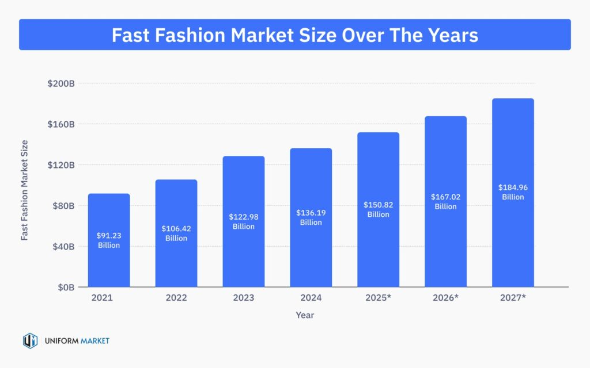

Figure 1: Bar graph showing global fast fashion market size over the years (Uniform Market)
Fast fashion industries and their waste generation will only continue to rise as the global market size increases and the cycle of production and disposal of garments continues to get faster. Given that fast fashion industries are one of the largest causes of waste generation and environmental impacts they bring, effectively preventing future impacts that will be deteriorated than now requires understanding of fast fashion industries’ origin, causes, and different possible ways to solve the issue.
History and origin of the fast fashion industry
Fast fashion industries evolved through technological, economic, and cultural shifts over a long period of time. During the pre-industrial era in the 19th century, garments were handmade and expensive, which made people own few clothes and repair them when needed. Then, the sewing machine was invented in 1830, making the production of garments less time-consuming and expensive. In the late 19th century and early 20th century, mass production began to be prevalent, allowing garments, especially ready-to-wear clothes more accessible and affordable for the public. After World War II, demand for trendy and affordable clothes began to increase with economic growth and consumerism prevailing in many countries, allowing the mass production of clothing to expand. During this period, fashion also shifted from being seasonal to trend-driven, with youth culture including the “baby boomer” generation responding to the shifting fashion trends. By the late 1970s, the fast fashion industry was fully shaped and defined, with its retailers expanding their businesses worldwide and swiftly producing massive garments by responding to recent trends. Today, with the development of social media and technologies, this type of industry’s pace of producing and releasing new products has been expedited, causing more environmental concerns around the world.
Short product lifespan
One of fast fashion’s defining traits is the extremely short lifespan of products. Due to the rapid introduction of new trends and new products presented by fast fashion retailers, consumers of those items are encouraged to purchase more often and dispose of them more quickly. In fact, garment usage has decreased by approximately 36% over the past 15 years, and nowadays, clothes are merely worn 7 to 10 times before being disposed of. This decline in garment usage before its disposal indicates how fast fashion trends are driving consumers to only think about the consumption of new products to follow recent trends and not consider the environmental impacts they bring by following the cycle of overproduction and overconsumption.
Types of waste generated
Waste generation from fast fashion industries is prevalent at every single stage of cycle of garments, from production to consumption. These wastes can be separated into three types: production waste, consumption waste, and specific by-products and waste. During garment production, there are always proportions of fabrics discarded. It is estimated that every garment production disposes 15-20% of textile material on average as waste, and in a mass production line, waste generated only from the production stage must be considerable. The production stage creates hazardous chemical waste as well. As the production of garments involves chemical processes such as dyeing, fabric treatment, and fabric finishing, there are wastes of chemical solutions, paints, and toxic substances that may contaminate the environment. There are more than 15,000 chemicals used in textile manufacturing and production, and these chemicals lead to toxic impacts on the environment. In the consumption stage, it is estimated that 92 million tonnes of clothing are discarded every year around the globe, and only a small amount of them are being recycled or reused. With the continuous rise of the fast fashion industry, the number of times people wear the garments will decrease, and the disposal of them will keep increasing. Lastly, specific by-products such as leather and textile materials derived from animals may become toxic when they get disposed. Synthesized fabrics also generate wastes, specifically microplastics, eventually causing water and air pollution and infiltrating food systems.
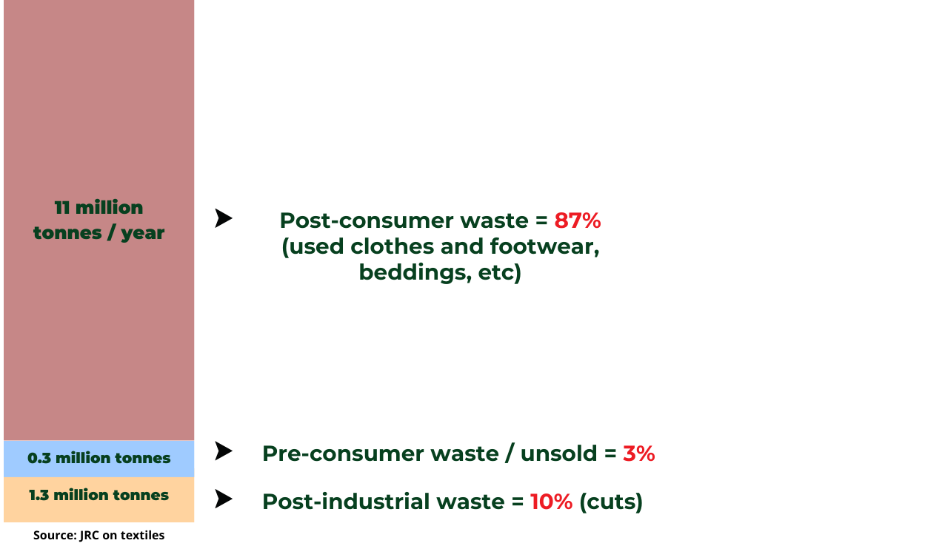
Figure 2: Composition of textile waste: post-consumer, pre-consumer, and post-industrial in Europe
Different waste disposal methods and their environmental effects
Landfilling
Landfilling is one way of dealing with massive amounts of waste, and almost 87% of total textile waste ends up in landfills. However, many textile wastes are synthetic materials that do not biodegrade, lasting in the landfills for more than a hundred years. As disposed wastes increase with fast fashion industries’ overproduction and overconsumption model, the capacities of landfills are significantly decreasing globally. Moreover, when textile waste decomposes, it emits greenhouse gases; considering the massive amount of waste in landfills, greenhouse gas emissions from textile decomposition become one of the causes of climate change.
Incineration

Incineration is another waste dealing method used to reduce the volume of waste when landfilling capacity is limited, and thus it is often viewed as environmentally friendly. However, during the burning process of textile waste, harmful pollutants are released from synthetic fibers and garments, which requires a sophisticated filtration system.

Major Countries and Organizations Involved
Fast fashion retailers
Fast fashion retailers such as Zara, H&M, Shein, and Uniqlo are known for their rapid production cycles and frequent introduction of new trends in their marketplace. Such companies have an extremely fast process of turning garments from the designing stage to the selling stage in actual stores, with Zara carrying out the process in only 15 days at the fastest. This process reflects how fast the productions of these companies are being carried out and how these companies crave quick reflections of recent trends and styles that people start to pursue. Therefore, dealing with these companies that are considered as one of the most influential factors driving the fast fashion industry in the globe will be required when addressing environmental issues caused by these companies’ overproduction and overconsumption that they require to their shoppers.
China
China is the largest clothing and textile exporter and the largest generator of textile waste, being responsible for 65% of the world’s clothing production. Factories of many fast fashion retailers such as Shein and Temu are located in China, making China one of the biggest textile waste generators. With these factories, it is estimated that 20-26 million tonnes of textile waste are generated in China annually. With China being a major source of textile waste and environmental impacts it brings, larger future impacts will be inevitable; thus, it is highly significant to address waste generation from China specifically.
United States
The United States is also a major country involved in this issue, with 17 million tonnes of textile waste being generated annually and approximately 11 million tonnes of it ending up in landfills. The amount of textile waste in the US has increased by roughly over 50% between 2000 and 2018, which indicates a decrease in landfill capacity as well as an increase in greenhouse gas emissions caused by the decomposition of textile wastes. Another challenge in managing waste in the US is that there isn’t a national requirement for states to collect and report Municipal Solid Waste (MSW) data. With this data limitation, it is difficult to manage the whole country’s waste generation.
United Nations Alliance for Sustainable Fashion
United Nations Alliance for Sustainable Fashion is a UN agency and allied organization working together to make the global fashion industry more sustainable by contributing to Sustainable Development Goals (SDGs). By implementing SDGs in fast fashion industries, the United Nations Alliance for Sustainable Fashion aims to reduce the industry’s waste stream and create sustainable fashion chains.
European Union (EU)
The European Union is an active contributor in addressing waste generation from fast fashion industries with several regulations to make fashion industries more sustainable. The EU has already adopted several regulations regarding fast fashion industries, including Extended Producer Responsibility (EPR) and Corporate Sustainability Due Diligence Directive (CSDDD), to improve the overall sustainability of the fast fashion industry.

Timeline of Events
Date | Description of event
March 14th, 2019 | UN Alliance for Sustainable Fashion established
December 14th, 2022 | International Day of Zero Waste
March 2nd, 2023 | Sustainability and Circulatory in the Textile Value Chain – A Global Roadmap

Relevant UN Treaties and Events
There isn’t a previous record of resolutions or events that specifically address waste generation from the fashion industry itself; however, there are notable reports and events that have broadly addressed issues regarding waste from the fashion and textile sector within UN initiatives.
- Sustainability and Circulatory in the Textile Value Chain – A Global Roadmap, 2 March 2023

Previous Attempts to Solve the Issue
EU Waste Framework Directive (WFD)
The EU Waste Framework Directive is the EU’s main legislative tool for waste management. In 2025, a revision was made, mainly targeting textile waste, which included contents regarding requirements of separate collection of textile waste, Extended Producer Responsibility, and export of textile waste. This framework, therefore, was considered a significant step toward improving the sustainability of the industry and reducing the environmental impacts it causes.
The Fashion Pact
The Fashion Pact is a global agreement with over 60 fashion and textile companies, promoted in 2019. Companies within this coalition are committed to sustainability goals regarding fast fashion industries, including reducing waste generation. They also commit to using at least 25% low-impact materials or even 100% recycling materials. By doing so, they aim to foster circular economic principles in their industry.
International Day of Zero Waste
International day of zero waste marks March 30 of each year as the day of zero waste in order to highlight the urgent need for global waste management. The creation of this day was introduced by Türkiye and other countries during a conference held on December 14, 2022, and was officially started in 2023. This creation of day aims to raise public’s awareness about significant environmental, social, and economic impacts the waste generation brings and to encourage zero-waste practices to prevent further impacts.
Possible Solutions
Since environmental impacts coming from waste generated in fast fashion industries involve a number of multinational companies, international agreements and regulations are needed in order to effectively promote sustainability in the fast fashion industry and reduce waste generation. Establishing international regulation requiring companies to use low-impact materials is a key solution for this issue. Without global companies, including fast fashion retailers, reducing the impact that clothing materials have in the production stage, the impacts from the post-production stage will only increase, leading to ineffective actions. Reducing waste generated from the designing and sampling process is another way of reducing waste generated during production. The sampling process often involves physical samples, which create a considerable amount of waste from fabric scraps and unused prototypes. Thus, reducing waste generated from this process will also help to reduce the overall waste generation. Another way to minimize the waste is to promote secondhand markets. Secondhand markets significantly extend the lifespan of garments and reduce the unnecessary disposal of garments made by primary consumers. With these markets, the circular economy will be promoted more effectively. Another possible solution is establishing Corporate Social Responsibility (CSR) model in fast fashion industry. Since CSR pushes brands to produce with materials that can be repaired and recycled and pursue sustainable economy in industry, CSR practices in fast fashion industry are going to be an effective way to promote sustainability in the overall cycle of fast fashion industry.

Bibliography
Campbell, Olivia. “Fashion’s Big Waste Problem: How Do Brands Manage Their Impact? | Withersworldwide.” Withersworldwide.com, 2018, www.withersworldwide.com/en-gb/insight/read/waste-management-in-the-fashion-industry-legal-perspectives-and-sustainable-solutions.
Cardona, Nancy. “Environmental Impact of Fast Fashion Statistics.” UniformMarket, UniformMarket, 3 Feb. 2025, www.uniformmarket.com/statistics/fast-fashion-statistics.
David Suzuki Foundation. “The Environmental Costs of Fast Fashion.” David Suzuki Foundation, 2025, davidsuzuki.org/living-green/the-environmental-cost-of-fast-fashion/.
Gallina, Nicole. “What Is the Impact of Fashion on China?” Www.linkedin.com, 29 Nov. 2022, www.linkedin.com/pulse/what-impact-fashion-china-nicole-gallina.
Lai, Olivia. “7 Fast Fashion Companies Responsible for Environmental Pollution.” Earth.org, Earth.org, 15 Oct. 2022, earth.org/fast-fashion-companies/.
Luong, Irene. “What Is Fashion Product Life Cycle? How a POS System Helps Fashion PLM.” World’s #1 POS for Magento, 4 Aug. 2022, www.magestore.com/blog/fashion-product-life-cycle/.
Maiti, Rashmila. “The Environmental Impact of Fast Fashion, Explained.” Earth.org, 20 Jan. 2025, earth.org/fast-fashions-detrimental-effect-on-the-environment/.
Matthews, Graham. “Fashion Waste Facts and Statistics.” Business Waste, 16 Jan. 2024, www.businesswaste.co.uk/your-waste/textile-recycling/fashion-waste-facts-and-statistics/.
McKinsey & Company. “What Is Fast Fashion?” McKinsey & Company, McKinsey & Company, 23 Jan. 2025, www.mckinsey.com/featured-insights/mckinsey-explainers/what-is-fast-fashion.
Moro, Serena. “Fashion Pact: Fashion Leaders’ Commitment to Sustainability.” Www.cikis.studio, 28 Jan. 2021, www.cikis.studio/en/article/fashion-pact-fashion-leaders-sustainable-practices.
Nhu, Quynh Do, et al. “The Secret to Fixing Fast Fashion’s Waste Problem.” Corporate Knights, 29 Sept. 2023, www.corporateknights.com/category-circular-economy/fixing-fast-fashions-waste-problem/.
“Overproduction.” LIGS University, 2014, ligsuniversity.com/overproduction/.
Petrie, Laila. Sustainability and Circularity in the Textile Value Chain. 2 Mar. 2023.
Rominger, Alma. “The History & Rise of Fast Fashion: From the 18th Century to Today.” Cory Ames, 20 July 2023, coryames.com/history-of-fast-fashion/.
Segal, Mark. “EU Parliament Adopts Rules Targeting Fast Fashion by Making Producers Pay to Recycle Textiles.” ESG Today, 13 Mar. 2024, www.esgtoday.com/eu-parliament-adopts-rules-targeting-fast-fashion-by-making-producers-pay-for-sorting-recycling-textiles/.
Shedlock, Karen, and Stephanie Feldstein. AT WHAT COST? UNRAVELLING the HARMS of the FAST FASHION INDUSTRY. 2023.
State of Matter. “10 Scary Statistics about Fast Fashion & the Environment.” State of Matter Apparel, 11 Dec. 2023, stateofmatterapparel.com/blogs/som-blog/10-scary-statistics-about-fast-fashion-the-environment.
“Textile Waste.” Business Waste, 23 July 2025, businesswaste.com/waste-types/textile-waste/. Accessed 26 July 2025.
UN Alliance for Sustainable Fashion. “The UN Alliance for Sustainable Fashion.” The UN Alliance for Sustainable Fashion, 2021, unfashionalliance.org/.
UNEP. “Five Ways to Reduce Waste in the Fashion Industry.” UNEP, 25 Mar. 2025, www.unep.org/news-and-stories/story/five-ways-reduce-waste-fashion-industry.
UN Habitat. “International Day of Zero Waste | UN-Habitat.” Unhabitat.org, 2023, unhabitat.org/international-day-of-zero-waste.
“Unsustainable Fashion and Textiles in Focus for International Day of Zero Waste 2025.” UN Environment, 27 Mar. 2025, www.unep.org/news-and-stories/press-release/unsustainable-fashion-and-textiles-focus-international-day-zero.
United States Government Accountability Office. “GAO-25-107165, TEXTILE WASTE: Federal Entities Should Collaborate on Reduction and Recycling Efforts.” Gao.gov, Dec. 2024, files.gao.gov/reports/GAO-25-107165/index.html#_Toc184736246. Accessed 26 July 2025.
vestyashop. “The History of Fast Fashion.” Vestyashop.com, 21 Apr. 2025, vestyashop.com/articles/the-history-of-fast-fashion/. Accessed 26 July 2025.
“Waste Framework Directive (WFD) - EURATEX.” EURATEX, 2023, euratex.eu/waste-framework-directive-wfd/.Petrie, Laila. Sustainability and Circularity in the Textile Value Chain. 2 Mar. 2023.

Appendix or Appendices
- Sustainability and Circulatory in the Textile Value Chain – A Global Roadmap - https://wedocs.unep.org/bitstream/handle/20.500.11822/42580/Sustainability_circularity_textile.pdf?sequence=3&isAllowed=y

