Forum: Environmental Commission
Issue: Addressing the role of education to prioritize climate change as a global issue to combat denialism
Student Officer: Sarah Kim
Position: President

Introduction
Climate change stands as one of the most pressing and complex challenges that humanity is currently facing. It is causing record-breaking temperatures, with recent years being the hottest on the record. Projection also indicates an 86% chance of the global average temperature exceeding 1.5 °C above the pre-industrial level in the next five years. This shift in temperature that has been observed over the past hundreds of years is the key factor that accelerates sea level rise and drives more frequent natural disasters such as wildfires, floods, and heatwaves, which result in a rise in climate refugees. Thus, its impacts are not only environmental but also deeply human. Despite this overwhelming scientific consensus, climate denialism, often caused by misinformation, vested interests, and psychological resistance, remains as a strong barrier to effective actions to address issues regarding climate change. With this being said, education prioritizing climate change emerges as a pivotal force to more effectively combat several urgent issues regarding climate change.
Education is recognized as a key requirement in addressing climate change by international bodies such as the United Nations and the United Nations Educational, Scientific and Cultural Organization (UNESCO). In a society with fully developed social media platforms and internet, misinformation and almost non-limited access to information that we do not know if verified or not, spread of any falsified information that cause climate change can happen at any time. Thus, strengthening the educational system about climate change and improving overall climate literacy is a step that we must take in order to combat denialism that thrives on cognitive biases, misinformation, and the deliberate spread of doubts.
With climate impacts intensifying at a rapid pace, prioritizing climate change within education is essential for overcoming denialism and fostering practical and proactive solutions that can effectively address climate issues.

Definition of Key Terms
Climate change
Climate change is a long-term change in average temperature and weather patterns that define Earth’s global climate. This shift in climate is primarily driven by human activities such as burning fossil fuels, which increases greenhouse gases and eventually raises the Earth’s global temperature. It is one of the most urgent environmental issues that humanity is facing today, including issues that are also deeply related to humans, such as the global health crisis and climate refugees around the world.
Climate literacy
Climate literacy is one’s understanding and acknowledgement of his or her influence on the climate. A person with good climate literacy understands essential principles of climate systems, easily accesses information about climate-related issues without being heavily affected by spread of misinformation, and makes responsible decisions by considering environmental impacts they may bring.
Climate denialism
Climate denialism refers to the rejection of the overwhelming scientific consensus on climate change and its impacts on the environment. Denial among people is often caused by campaigns by industrial, political, and ideological interests and conservative economic policies. Climate denialism often become one of the biggest hindrance of effective actions to reduce climate change, and thus, it must be tackled first when dealing with climate issues.

Background Information
Climate change
Climate change, a long-term shift of Earth’s weather patterns, has been threatening almost every single part of our Earth, from ecosystems to human health. The world has been warming up rapidly over the past 100 years, and he the speed of Earth’s temperature increasing has never been this fast before. Following the trend of increasing temperature, in 2024, the temperature reached its hottest record. With a continuous rise in the climate, the need for practical and effective solutions for the issue has become more urgent than ever, and it is crucial to understand the different causes and consequences of climate change in depth.
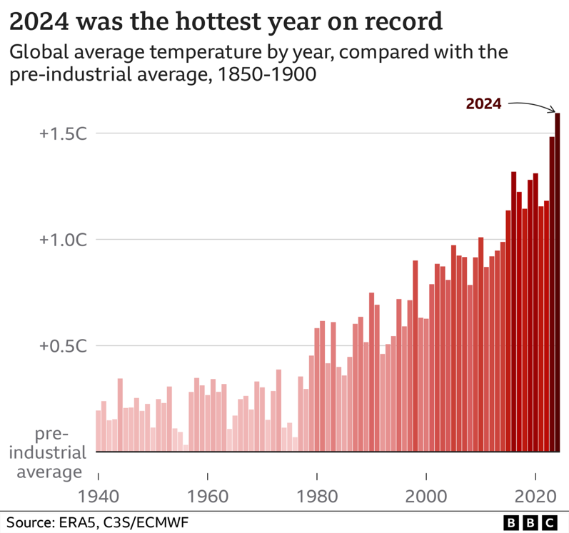
Figure 1: annual global average temperature compared with pre-industrial average, 1940 - 2024
Causes
Major causes of climate change are dominated by human activities, while there are some natural factors playing a minimal role in the change. The biggest and primary cause of the shift is greenhouse gas emissions. Greenhouse gas emissions trap heat and lead to global warming and are often produced through human activities such as burning fossil fuels, deforestation, and agriculture. Burning fossil fuels is the largest contributor of greenhouse gas emissions, which release a considerable amount of carbon dioxide to Earth’s atmosphere and nitrous oxide during the process of generating energy for transportation and industry from them. Another factor is deforestation. Deforestation involves cutting down the forests, leading to reduction in the number of trees to absorb carbon dioxide from the atmosphere and release oxygen in return. With a decrease in the number of trees, the absorption of carbon dioxide done by trees weakens and more amount of carbon dioxide stays in the atmosphere. Moreover, during the process of cutting or burning of trees, a large amount of carbon dioxide that had been stored in the trees gets released back into the air, adding to greenhouse gases. Lastly, methane from livestock digestions also contribute to more greenhouse gases. Specifically, ruminant animals including cattle, sheep, and goat release methane produced during digestion through burping. A single cow can produce up to 264 pounds of methane annually, indicating the large contribution of livestock on the greenhouse gas emission.
Consequences
The consequences of climate change are countless. It results rise in global temperature, leading to more frequent extreme weather; an increase in the frequency of natural disasters, which creates many refugees; and loss of critical resources, which leads to difficulties in ensuring necessities for economic development and human survival. Rise in global temperature has resulted in more frequent and intense heatwaves and loss of polar ice while accelerating the rise in sea levels and threatening several ecosystems around the world as well. With extreme weather patterns that create environments that are difficult for different organisms to survive, many animals or organisms are losing their ecosystems and are in danger of becoming extinct. Also, natural disasters become more common and severe. Particularly, disasters like floods, storms, droughts, and wildfires are intensified by high temperatures. In fact, the number of climate-related disasters has tripled in the last 30 years. With the continuously rising Earth’s temperature, the intensity and frequency of these disasters will only increase, which indicates an urgency of the need for actions to solve this issue.
Climate denialism
Climate denialism, a rejection or dismissal of the scientific consensus of climate change, is one of the biggest hindrances to the effective implementation of actions that aim to reduce the impacts of climate change around the globe. It also makes people overlook and underestimate the environmental impacts climate change brings and discourages them from fully supporting actions that many are taken to reduce the impacts. It is generally caused by propagated by corporations or political groups that consider climate actions as a threat to their economy or political power. These propagandas are done through the spread of misinformation, emphasis on uncertainties in climate models or projections, and data that are picked to be shown and emphasized to the public.
History
Climate denialism began taking its shape in the mid-20th century, with fossil fuels from the US being a potential human activity to cause an increase in global temperature in the 1960s. However, despite the acknowledgement made, several industries using fossil fuels or harmful materials promoted the idea that carbon dioxide is beneficial for the planet. This marks one of the first misinformation regarding climate change made by industries for their own benefits to the public. By the 1980s, more climate denial movements emerged, with groups aiming to create confusion and delay policy establishments by emphasizing the uncertainties of scientific consensus and promoting skepticism about global warming in the public. In the 1990s, public concerns about climate change increased, but efforts of denialist groups were still present as they tried to disprove the science that presented global warming. When it came to the 2010s, industry-funded denial efforts were softened; however, climate denial remains as an obstacle to actions aiming to reduce climate change.
Current prevalence
As of early 2025, there are roughly 15% of people who deny the reality of climate change in the US; even though the number itself does not seem large, these denials are deeply linked with the challenge of establishing effective actions regarding climate change. Moreover, social media platforms are fully developed today, increasing the possibilities of people receiving misinformation very easily. Influential individuals or groups also accelerates the spread of misinformation to the public. As these individuals are widely known by the public, a single post with hidden skepticism of climate change can influence millions of users. Moreover, social media uses algorithm mechanism that can make the same information appear repetitively. This feature of social media, thus, leads to instillation of misinformation and eventually create strong climate denialism. With this new factor that helps causes of denialism spread more widely and quickly, there is a potential of having more denials around the globe. Thus, it is crucial to address climate denialism in the public when practical and feasible solutions are key to solving this issue.

Major Countries and Organizations Involved
United Nations Educational, Scientific and Cultural Organization (UNESCO)
UNESCO is a specialized UN agency that aims to accelerate climate change education and greening education worldwide. UNESCO supports countries in revising educational curricula, training teachers, and fostering critical thinking skills in individuals to actively combat climate denialism.
Italy
Italy is the first country to mandate climate change and sustainability education in public schools starting from the 2020-2021 school year. This education system also requires teachers to dedicate at least 33 hours per year to topics related to climate change. This curriculum is internationally recognized as a model for embedding climate education in all grade levels, showing an example of national regulation that resulted in improved educational outcomes.
United Nations Framework Convention on Climate Change (UNFCCC)
UNFCCC is an international treaty guiding a global response to climate change, and it recognizes education as a key component in maximizing actions taken to address climate issues. It encourages nations to implement climate change education, training, and public awareness into their strategies. Collaborating with this organization and referring to the previous attempts made in the organization will be helpful when formulating feasible and effective solutions for prioritizing climate change in education.
Office for Climate Education (OCE)
OCE is an international organization that aims to promote and develop climate change education with its particular focus on supporting teachers and fostering robust educational systems in developing countries. It plays a significant role in advancing the global agenda for climate change education and helping societies become more resilient and prepared for the climate crisis.

Timeline of Events
Date | Description of event
December 12th, 2023 | The United Nations Conference on Climate Change held in the UAE

Relevant UN Treaties and Events
- Lima Ministerial Declaration on Education and Awareness-raising, 3 December 2014
- Paris Agreement, 12 December 2015
- Declaration on Common Agenda for Education and Climate Change, 9 December 2023

Previous Attempts to Solve the Issue
Lima Ministerial Declaration on Education and Awareness-raising
Lima Ministerial Declaration on Education and Awareness-raising is a formal commitment made during the conference held in Lima, Peru, in 2024. It emphasizes the critical role of education in combating climate denialism, including suggestions such as encouraging nations to incorporate topics related to climate change into school curricula, calling for international cooperation and complementary initiatives, and emphasizing the importance of public participation in implementing climate policies and actions.
Paris Agreement
The Paris Agreement is an international treaty founded in 2015 under the United Nations Framework Convention on Climate Change (UNFCCC). Its central aim is to limit global warming to below 2°C above the pre-industrial level, and with this aim, it proposes plans for solutions to the issue. One example of this is a plan for Nationally Determined Contributions (NDCs), which requires nations to submit their climate action plans and adaptation plans and update them every five years.

Possible Solutions
Addressing the role of education to prioritize climate change as a global issue to combat denialism not only talks about climate change itself, but also about education and denialism that the public commonly has. In order to solve this issue, mentioning all three factors mentioned in the issue itself is important. Having only one of these factors solved will not lead to solving all factors of the issue itself, and in order to do so, the range of content will become bigger with more solutions needed to fulfil the urgent call for an action. First, encouraging nations to mandate climate education in public schools at all levels can be one of the ways to prioritize climate change in education. Since many nations currently do not have a strong mandate or national regulations for schools, policy to mandate prioritizing of climate change in their curricula will be needed. Moreover, enhancing public awareness is a key solution to this issue. As climate denialism comes from the public who are vulnerable to misinformation, it is crucial to correct the misunderstanding of any information related to climate change and reduce the denialism. Using social media platforms can be an effective way to raise public awareness about climate change. Just as spread of misinformation on social media, a proper use of social media platform will be a quick way to correct misinformation that were present in the public and to spread correct and urgent information about climate change to the public. Strengthening teachers' training is also a way of improving education. Since teachers are the ones who deliver information to students, teachers with clear acknowledgment are needed in order to prevent further misunderstanding among students.

Bibliography
“About Us | Office for Climate Education.” Oce.global, 2018, www.oce.global/en/about-us. Accessed 27 July 2025.
Appel, Deirdre. “Italy Mandates Climate Change Education for All Students.” NYC Food Policy Center (Hunter College), 2 Dec. 2019, www.nycfoodpolicy.org/italy-mandates-climate-change-education-for-all-students/.
BBC. “What Is Climate Change? A Really Simple Guide.” BBC News, 10 Jan. 2025, www.bbc.com/news/science-environment-24021772.
DECLARATION on the COMMON AGENDA for EDUCATION and CLIMATE CHANGE at COP28.
Goldson, Ben. “How Did Climate Denial Get Its Start, and What Does Anti-Government Ideology Have to Do with It?” Public Interest Media, 2023, www.thebigq.org/2023/11/28/how-did-climate-denial-get-its-start-and-what-does-anti-government-ideology-have-to-do-with-it/. Accessed 27 July 2025.
Lewandowsky, Stephan, et al. “Seepage: Climate Change Denial and Its Effect on the Scientific Community.” Global Environmental Change, vol. 33, July 2015, pp. 1–13, www.sciencedirect.com/science/article/pii/S0959378015000515, https://doi.org/10.1016/j.gloenvcha.2015.02.013.
Mendy, Laila, et al. “Counteracting Climate Denial: A Systematic Review.” Public Understanding of Science, vol. 33, no. 4, 20 Jan. 2024, https://doi.org/10.1177/09636625231223425.
Mullinix, Nayiri. “Nearly 15% of Americans Deny Climate Change, Study Finds | the University Record.” Record.umich.edu, 14 Feb. 2024, record.umich.edu/articles/nearly-15-of-americans-deny-climate-change-study-finds/.
Team, Terrascope. “Understanding Greenhouse Gases and Climate Change.” Terrascope.com, Terrascope Pte. Ltd., 7 June 2024, www.terrascope.com/blog/understanding-greenhouse-gases-and-climate-change.
UNESCO. “UNESCO at COP28: Making Education the Long-Term Solution to the Climate Crisis.” Unesco.org, 2023, www.unesco.org/en/articles/unesco-cop28-making-education-long-term-solution-climate-crisis.
UNFCCC. “The Paris Agreement.” United Nations Climate Change, United Nations, 2015, unfccc.int/process-and-meetings/the-paris-agreement.
United Nations. “UNFCCC.” Unfccc.int, United Nations, 2023, unfccc.int/.
United States Environmental Protection Agency. “Agriculture and Aquaculture: Food for Thought.” Www.epa.gov, Oct. 2020, www.epa.gov/snep/agriculture-and-aquaculture-food-thought.
“What Is Climate Literacy?” North American Association for Environmental Education, naaee.org/programs/coalition/resources/what-climate-literacy.

Appendix or Appendices
- Lima Ministerial Declaration on Education and Awareness-raising: https://unstats.un.org/sdgs/tierIII-indicators/files/Tier3-13-03-01.pdf
- Paris Agreement: https://unfccc.int/resource/docs/2014/cop20/eng/l01.pdf

