Forum: World Health Assembly (WHA)
Issue: Addressing global threat of antiviral drug resistance and its implications on public health
Student Officer: Eunsol Kim
Position: President

Introduction
Antimicrobial Resistance (AMR) is emerging as a silent pandemic, particularly in antivirals, and is expected to cause 10 million deaths per year by 2050 if left unaddressed. The misuse of antivirals during COVID-19, including the indiscriminate prescribing of oseltamivir (Tamiflu) in 78% of mildly ill patients, has accelerated resistance in influenza and HIV strains. This crisis threatens to reverse decades of progress: 5.7 million people living with HIV are now resistant to first-line antiretrovirals, and 90% of seasonal influenza A/H1N1 strains are resistant to adamantane. The World Health Assembly (WHA) should prioritize on standardising global surveillance, antimicrobial stewardship, equitable access to new antivirals, and impeding the risk of outbreaks through one health integration.

Definition of Key Terms
Antiviral Drug Resistance (AVR)
Antiviral drug resistance occurs when a virus stops responding to an antiviral medication. Specifically, the virus changes, making an antiviral drug less effective.
One Health Approach
A collaborative, multidisciplinary framework that acknowledges that the health of human and animal is closely connected to the health of animals and our shared environment. It aims to attain optimal health outcomes by integrating efforts across various sectors, including public/animal/environmental health.
Antimicrobial Stewardship
A coherent set of actions which promote using antimicrobials responsibly. This involves ensuring the right drug, route of administration, and duration of therapy for patients, with the goal of optimizing patient outcomes, reducing antimicrobial resistance, and mitigating adverse events.
Genomic Surveillance
Involves sequencing the genetic material of pathogens and identifying changes linked to the origins or characteristics of a disease. Viruses can be tracked using genomic sequence data collected by Centres for Disease Control and Prevention (CDC).

Background Information
Escalating AVR crisis
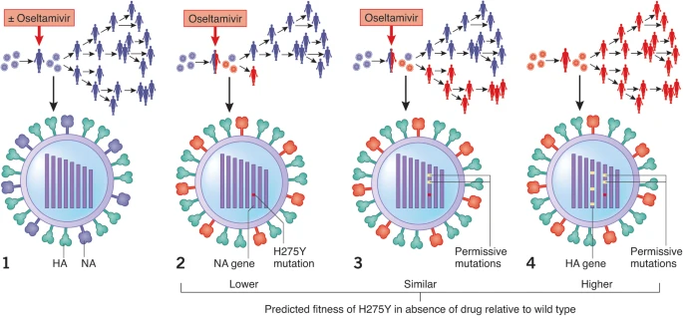

Image #1: The spread of oseltamivir-resistant influenza viruses depends on their fitness relative to susceptible wild-type viruses –The Ongoing Battle
Given the unprecedented risk of human spread of the highly pathogenic avian influenza strain H5N1 and the great challenge of developing an effective influenza vaccine, antiviral drugs will play a pivotal role in combating emerging pandemic strains. Nevertheless, the crucial limitation to the use of these drugs is the evolution of highly contagious drug-resistant viral strains. It is an increasing concern in immunocompromised patient populations, where ongoing viral replication and prolonged drug exposure lead to the selection of resistant strains. In this regard, managing drug resistance includes optimising host factors and drug delivery, selecting alternative therapies based on knowledge of resistance mechanisms, and developing new antiviral agents.
Drivers of Resistance
Overmedication with antiviral drugs could significantly engage to the development of drug resistance in viruses. When viruses are repeatedly exposed to antiviral drugs, especially if they are not at the optimal dose or duration, they can mutate and evolve, becoming resistant to the drug. Due to these factors, the antiviral drug may not be able to effectively control the viral infection, leading to extended illness. Moreover, the infection may not respond to the usual antiviral treatment, requiring alternative medications or even a change in treatment strategy.
Impacts of Economic and Health
Antiviral drug led to enlarged healthcare costs due to longer treatment durations, more expensive drugs, and higher hospitalization rates. Illness resulting from resistant infections is capable to lead to reduced productivity, impacting both individuals and the broader economy. Moreover, estimates have suggested that antimicrobial resistance including antiviral resistance could pilot to trillions of dollars in GDP losses annually by 2050. In addition, Health impacts include increased mortality, particularly for those who compromised immune systems, and the potential for outbreaks with limited treatment options. Furthermore, in some cases, antiviral resistance may present to outbreaks, as the virus can spread more easily, and treatment options become less effective.
AVR Crisis
The AVR crisis have evolved through distinct stages marked by significant developments in different regions. During the initial emergence of resistance, the HIV/AIDS pandemic exposed the vulnerabilities of single-drug therapy approaches, with resistance to zidovudine (AZT) first appearing the United States in 1989 and spreading to 50% of treated patients by 1993. Thailand faced similar issues with 25% of HIV patients taking AZT showing resistance by 1997 by prompting the WHO to recommend combination therapy. At the same time, adamantane-based drugs used to treat influenza lost their effectiveness by 2005, with 90% of H3N2 strains developing resistance, making a switch to neuraminidase inhibitors inevitable.
Lessons learned from past failures highlight the risks of single-therapy approaches, as seen during the AZT era of HIV, and gaps in surveillance systems are also pointed out as a problem. Only 30% of (LMICs) have reported influenza resistance data. Neglect of the One Health approach, such as the unregulated use of antiviral drugs in Vietnamese poultry, has also contributed to the promotion of resistance. These examples underscore the need for coordinated global action to mitigate the growing threat of AVR.

Major Countries and Organizations Involved
United States
Especially for influenza and other viruses, US takes AVR as a severe concern, as it can reduce the effectiveness of treatment and potentially lead to more extreme illness or treatment failure. The US CDC actively monitors antiviral resistance in circulating influenza viruses and contribute guidance to healthcare professionals on appropriate treatment strategies.
India
India undergoes serious challenges related to AVR, particularly for HIV and influenza A viruses. The high prevalence of drug-resistant HIV mutations in India and limited access to drug resistance testing, especially among key populations, raise concerns about treatment effectiveness and the transmission of resistant strains. India is also a major consumer of antibiotics, and both misuse and overuse of antibiotics contributes to the development of AMR, which can also affect antiviral treatment.
Global Antimicrobial Resistance and Use Surveillance System (GLASS)
GLASS contributes to the fight against AMR by providing standardized framework for data collecting, analysing, and sharing AMR data from contributing nations, including antimicrobial consumption (AMC). In particular, the system facilitates the collection of data on AMR in common bacteria causing human infections, as well as data analyses and summarizes it in global reports. GLASS data is used to inform policy decisions related to antimicrobial use and resistance; for instance, the data on AMC is often utilized to monitor progress towards global targets for antibiotic usage.
Global Fund
Global Fund is a major international financing institution that plays a vital role in the global struggle against AVR, by providing financial resources to low- and middle-income countries (LMICs) to support prevention, treatment, and care programs. It further collaborates with a wide range of partners, including nation’s governments, civil society organizations, and other additional international bodies.

Timeline of Events
Date | Description of event
1960-1990~ | First antiviral drugs were often found by chance, repurposing compounds initially developed for other purposes. Early research focused on identifying compounds that could inhibit viral replication in cell culture. Furthermore, researchers recognized that examining how viruses mutate to become resistant could reveal information about the drug’s mechanism of action and the virus’s biology.
May 2015 | WHA adopted the Global Action Plan on AMR in in 2015, occurred during the 68th WHA. It outlines strategies to address the growing threat of AMR and attain the goal of ensuring effective and safe medicines for treating and preventing infectious diseases.
2019 | South Africa began reporting cases of dolutegravir-resistant HIV in 2019, during the time when the country transitioned to dolutegravir-based antiretroviral therapy (ART).
February 2024 | WHO updates the List of Medically Important Antimicrobials to include novel antivirals, adding new categories based on the importance of antimicrobials in human medicine and the threat of AMR. It aims to lead the appropriate use of antimicrobials in both human and non-human sectors to mitigate AMR.

Relevant UN Treaties and Events
- Political Declaration on AMR, 5 October 2016
  - First UNGA resolution on AMR, which urged nations to adopt national action plans about the issue (A/RES/71/3).
- Political Declaration on HIV/AIDS, 8 June 2016
  - Targeting to reduce HIVDR in children to <10% by 2020(achieved in 8/21 priority countries) and providing third-line ARVs in all nation formularies (A/RES/70/266)

Previous Attempts to solve the Issue
WHO Global Action Plan on HIV Drug Resistance (2017-2021)
WHO’s action plan focused on preventing the emergence and spread of drug-resistant HIV through various interventions such as a promotion of adherence to ART and avoiding new HIV infections. The plan emphasized the necessity for robust surveillance systems to track the prevalence and trends of HIV drug resistance; it further encouraged research into novel drugs and their treatment strategies to overcome the resistance. Ultimately, it aimed to reinforce laboratory capacity for drug resistance monitoring and testing. However, this attempt met a failure of inadequate monitoring, challenges in scaling up effective interventions, and the need for greater country ownership and sustainable investment. Many countries struggled to implement the monitorization of HIVDR and make it effective, leading to gaps in data collection and delayed reactions to arising resistance.
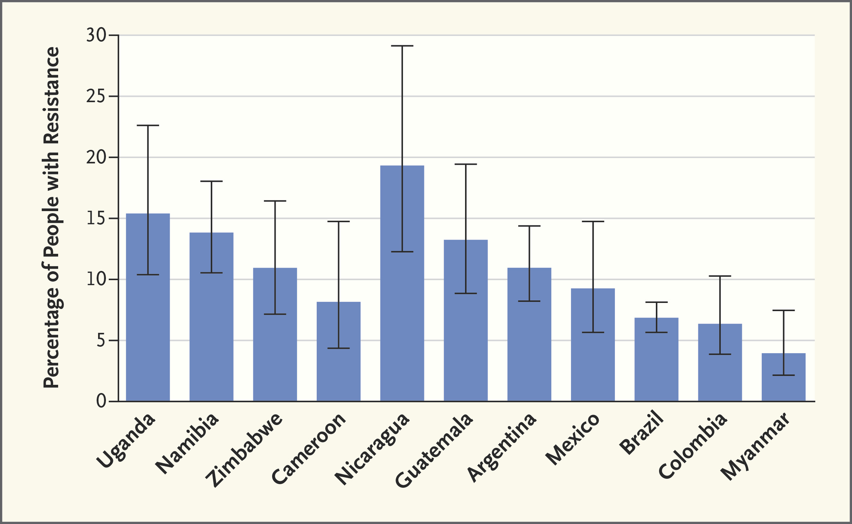

Graph #1: Pretreatment HIV Drug Resistance to Nonnucleoside Reverse Transcriptase Inhibitors in 11 Countries - HIV Drug Resistance
Moreover, in 2017, there were concerns about possible funding cuts to global health initiatives, including HIV, which could adversely affect HIV prevention, treatment, and efforts to combat drug resistance. The United Nations agencies UNAIDS and WHO have committed to the goal of ending the AIDS pandemic as a public health threat by 2030, with 90% of people living with HIV knowing their status, 90% of those living with HIV receiving ART, and 90% of those receiving treatment achieving sustained virological suppression by 2020.
Pandemic Influenza Preparedness(PIP) Framework (2011)
Enhanced Virus Sharing
The framework aims to advance sharing of the pandemic potential of influenza viruses through the Global Influenza Surveillance and Response System (GISRS), industry, and other stakeholders to achieve these goals.
Equitable Access to Benefits
The Framework establishes two mechanisms to facilitate access to benefits: Standard Material Transfer Agreement-2(SMTA-2) which is a contracting mechanism to enable WHO to secure advance access to specific percentages of pandemic response products such as vaccines and antivirals, and a yearly Partnership Contribution(PC) that is paid to WHO by influenza vaccine, diagnostic manufacturers that use GIRSRS. In sum, the total amount that WHO is to receive yearly is US $28 million that is based on the estimated costs to run the WHO GISRS. Besides, since 2013, PC funds received by WHO has been allocated as 10% of PC funds to the PIP Secretariat, 30% of the remainder for response in the event of an influenza pandemic and 70% for preparedness.
Access and Benefit Sharing
PIP aims to promote impartial and equitable access to benefits such as vaccines and antiviral medicines that emerge from sharing.

Possible Solutions
Mandatory Global AVR Surveillance Network
To tackle emerging antiviral resistance, a pathogen-specific immediate surveillance system is recommended to be established under the coordination of WHO. This network would mandate standardized reporting of resistance data for influenza, HIV, and SARS-CoV-2 in all member states. For instance, during the flu season around 2022-2023, only 40% of countries reported neuraminidase inhibitor resistance, delaying the global alert for the H275Y mutation. In this aspect, it is looked forward to measuring all nation’s success by 2027, with a public dashboard to track resistance hotspots.
Equitable Access to Next-Generation Antivirals
The WHO Pandemic Accord must include patent exemptions and technology transfer for drugs prone to resistance. Particularly, during COVID-19, the patent exclusivity led to an 18-month delay in generic production in LMICs, exacerbating the hazard of resistance. Therefore, it is recommended to:
- Mandate that at least 20% of antiviral profits go to LMIC manufacturing hubs (e.g., mRNA vaccine in South Africa).
  - Capacity implementation: We fund infrastructure for the entire antiviral production process (e.g., molnupiravir synthesis in India and Nigeria).
  - Cost reduction: Local production can reduce prices by 30–60%, as seen in the case of generic HIV antiretrovirals (MSF Access Campaign, 2023).
  - Establish a profit-sharing system linked to transparent audits and applies penalties for non-compliance (e.g., reduction of patent extension periods).
- Prioritize antivirals that are considered to be anti-resistance.
  - Promote multi-drug regimens to reduce the risk of resistance, as successfully implemented in Botswana.
  - Monitoring and adaptation: Allow the access to mandatory participation in global surveillance that ensures real-time data on emerging resistance.
  - Update essential medicines lists for each nations annually based on resistance trends, as piloted in Kenya’s HIV program.

Bibliography
Antimicrobial Resistance with a Focus on Antibacterial, Anti-fungal, Antimalarial, and Antiviral Drugs Resistance, Its Threat, Global Priority Pathogens, Prevention, and Control Strategies: A Review. PubMed Central, 23 May 2025, pmc.ncbi.nlm.nih.gov/articles/PMC12103682/. Accessed 11 July 2025.

Antiviral Drug Resistance. PubMed Central, 5 Sept. 1998, pmc.ncbi.nlm.nih.gov/articles/PMC1113839/. Accessed 11 July 2025.

Antiviral Drug Resistance. Thebmj, 5 Sept. 1998, www.bmj.com/content/317/7159/660.short. Accessed 11 July 2025.

Antiviral Drug Resistance: Mechanisms and Clinical Implications. PubMed Central, 1 June 2011, pmc.ncbi.nlm.nih.gov/articles/PMC2871161/. Accessed 11 July 2025.

Antiviral Resistance. Cleveland Clinic, 6 Aug. 2022, my.clevelandclinic.org/health/articles/23217-antiviral-resistance. Accessed 11 July 2025.

Antiviral Resistance during Pandemic Influenza: Implications for Stockpiling and Drug Use. PubMed Central, 22 Jan. 2009, pmc.ncbi.nlm.nih.gov/articles/PMC2653495/. Accessed 11 July 2025.

Antiviral Use and the Effect of Drug Resistance on the Transmission Dynamics of Influenza. MedRxiv, Mar. 2025, www.medrxiv.org/content/10.1101/2025.03.10.25323668v1.full. Accessed 11 July 2025.

Eighth Replenishment Investment Case. Global Fund, 18 Feb. 2025, www.theglobalfund.org/en/investment-case/. Accessed 11 July 2025.

Emergence of Drug Resistance: Implications for Antiviral Control of Pandemic Influenza. Royal Society Publishing, 16 May 2007, royalsocietypublishing.org/doi/abs/10.1098/rspb.2007.0422. Accessed 11 July 2025.

Global Actin Plan on Antimicrobial Resistance. World Health Organization, 1 Jan. 2016, www.who.int/publications/i/item/9789241509763. Accessed 11 July 2025.

Global Action Plan on HIV Drug Resistance 2017-2021. World Health Organization, July 2017, iris.who.int/bitstream/handle/10665/255883/9789241512848-eng.pdf. Accessed 11 July 2025.

Global Antimicrobial Resistance and Use Surveillance System(GLASS). World Health Organization, www.who.int/initiatives/glass. Accessed 11 July 2025.

Global HIV Programme. World Health Organization, www.who.int/teams/global-hiv-hepatitis-and-stis-programmes/hiv/treatment/hiv-drug-resistance/global-action-plan-and-strategy-on-hiv-drug-resistance. Accessed 11 July 2025.

The Health and Economic Burden of Resistance. National Library of Medicine, www.ncbi.nlm.nih.gov/books/NBK577288/#:~:text=Most%20health%20problems%2C%20resistant%20infections%20included%2C%20hurt,after%20them%20(%20Tillotson%20and%20Zinner%2C%202017). Accessed 11 July 2025.

HIV Drug Resistance ? an Emerging Threat to Epidemic Control. New England Journal of Medicine, 26 Oct. 2017, www.nejm.org/doi/full/10.1056/NEJMp1710608. Accessed 11 July 2025.

HIV Drug Resistance Webinar: Report on the Global Action Plan on HIV Drug Resistance 2017-2021 and Perspectives for the Future. World Health Organization, 20 Nov. 2023, www.who.int/news-room/events/detail/2023/11/20/default-calendar/webinar-global-action-plan-on-hiv-drug-resistance-and-future-integrated-gap-on-hiv-hepatitis-and-stis. Accessed 11 July 2025.

Influenza Antiviral Drug Resistance. Central for Disease Control and Prevention, 25 Oct. 2022, www.cdc.gov/flu/treatment/antiviralresistance.html#:~:text=In%20the%20United%20States%2C%20nearly%20all%20recently,treatment%20of%20seasonal%20influenza%20A%20virus%20infections. Accessed 11 July 2025.

Karade, Santosh, et al. "HIV Drug Resistance following a Decade of the Free Antiretroviral Therapy Programme in India: A Review." International Journal of Infectious Diseases, vol. 66, Jan. 2018, pp. 33-41, https://doi.org/10.1016/j.ijid.2017.10.020. Accessed 11 July 2025.

New Report Documents Increase in HIV Drug Resistance to Dolutegravir. World Health Organization, 5 Mar. 2024, www.who.int/news/item/05-03-2024-new-report-documents-increase-in-hiv-drug-resistance-to-dolutegravir#:~:text=It%20also%20has%20a%20high,having%20high%20HIV%20viral%20loads. Accessed 11 July 2025.

The Ongoing Battle against Influenza: Drug-Resistant Influenza Viruses: Why Fitness Matters. Nature Medicine, 2012, www.nature.com/articles/nm.2954. Accessed 11 July 2025.

Pandemic Influenza Preparedness Framework. World Health Organization, open.who.int/2020-21/our-work/category/14/programme/14.003/about/about. Accessed 2025.

Primary Drug Resistance in South Africa: Data from 10 Years of Surveys. PubMed Central, 28 June 2012, pmc.ncbi.nlm.nih.gov/articles/PMC3358100/. Accessed 11 July 2025.

What Is Genomic Surveillance? Your Genome, www.yourgenome.org/theme/what-is-genomic-surveillance/. Accessed 11 July 2025.

What Is Genomic Surveillance? Centers for Disease Control and Prevention, 2 Dec. 2022, archive.cdc.gov/www_cdc_gov/coronavirus/2019-ncov/variants/genomic-surveillance.html. Accessed 11 July 2025.

What We Know about Clashes on the Thai-Cambodian Border. Aljazeera, 24 July 2025, www.aljazeera.com/news/2025/7/24/what-we-know-about-clashes-on-the-thai-cambodian-border#:~:text=The%20outbreak%20of%20fighting%20between,to%20a%20local%20media%20report. Accessed 26 July 2025.

When Going Back Is a Good Way Forward: What Assisted Voluntary Return Really Means. International Organization for Migration, 11 June 2025, lac.iom.int/en/blogs/when-going-back-good-way-forward-what-assisted-voluntary-return-really-means#:~:text=In%20simple%20terms%2C%20Assisted%20Voluntary,to%20make%20that%20return%20possible. Accessed 26 July 2025.
The World Health Organization's Response to Emerging Human Immunodeficiency Virus Drug Resistance and a Call for Global Action. PubMed Central, 13 Oct. 2017, pmc.ncbi.nlm.nih.gov/articles/PMC5853942/. Accessed 11 July 2025.

