Forum: Environmental Commission (ENV)
Issue: Reducing health risks caused by pollution from rapid urbanisation
Student Officer: Hugh Lee
Position: Deputy President

Introduction
As urban populations grow at an unprecedented rate, cities have become epicentres of both opportunity and crisis. Rapid urbanisation, particularly in less developed regions, often occurs without adequate infrastructure, planning, or environmental regulation. As a result, urban centres are experiencing alarming increases in air, water, and soil pollution, driven by unregulated industrial activity, traffic congestion, overcrowded housing, poor waste management, and limited access to clean water and sanitation. These environmental pressures are inseparable from public health: pollution in rapidly expanding cities is contributing to a growing burden of disease. In Delhi, for instance, concentrations of PM_{2.5} have frequently exceeded 270 µg m⁻³ (microgram per cubic metre), more than 270 times the World Health Organisation’s recommended limit of 10 µg m⁻³. This sharp disparity highlights the severe health risks posed by unchecked urban population, illustrating how environmental neglect in rapidly urbanising cities can lead to dangerously toxic air conditions.
This urban pollution crisis directly contributes to rising cases of asthma, cardiovascular disease, cancer and premature mortality, and poses threat to global progress towards Sustainable Development Goal (SDG) 3: Good Health and Well-being and SDG 11: Sustainable Cities and Communities. Tackling this issue requires more than emission control; it demands urgent and comprehensive interventions to reduce the health impacts already being felt across urban populations. These include expanding access to healthcare, improving disease surveillance systems, strengthening climate-resilient infrastructure, and integrating public health priorities into urban policymaking. In essence, effective responses must be both preventive and adaptive.

Definition of Key Terms
Urbanisation
Urbanisation is the increase in the proportion of people living in cities and urban areas. While often linked to economic growth, unregulated urbanisation can strain infrastructure and lead to environmental degradation and health risks.
Pollution
Pollution refers to the contamination of air, water, and soil by harmful substances. In urban areas, it results mainly from traffic, industrial activities, poor waste management, and overcrowding.
Waterborne diseases
Waterborne diseases are illnesses caused by drinking or coming into contact with contaminated water, often due to inadequate sanitation and poor waste management. Common diseases include cholera (severe diarrhoea), dysentery (bloody diarrhoea), and typhoid (intestinal fever), which are especially prevalent in informal settlements lacking clean water infrastructure.
Natural Increase
Natural increase is the first contributing factor of rapid urbanisation, as defined by the United Nations. Natural increase refers to the growth of the urban population due to higher birth rates than death rates within cities.
Migration
Migration is the second contributing factors of rapid urbanisation as defined by the United Nations. Migration includes the movement of people from rural areas or other countries into urban centres in search of better employment, education, and healthcare.
Reclassification
Reclassification is the third contributing factors of rapid urbanisation as defined by the United ations. Reclassification occurs when rural or peri-urban areas experience enough infrastructural, demographic, or economic development to be officially recognised as urban.
Background Information
As United Nations (UN) acknowledges, urbanisation is a defining trend of the 21st century, described as ‘a transformative force that can be harnessed to enhance economic growth, productivity and development’. However, ironically, this seemingly progressive shift has become one of the most pressing threats confronting the world across social, economic, environmental, and political dimensions. The problem continues to intensify, driven by accelerating population growth, unplanned migration, and widening gaps in infrastructure and governance. While urbanisation is often seen as a modern phenomenon, historians trace its origins back to the industrial revolution in the 18th century, when the rise of manufacturing industries in Europe and North America triggered a massive movement of people from rural to urban areas in search of work. This transformation brought about economic opportunity but also introduced serious challenges such as overcrowding, poor housing, informal settlements, inadequate sanitation, and the rise of pollutants,including coal smoke, untreated sewage, and industrial waste. These early patterns set a precedent that still echoes today. Urbanisation is a two-sided sword, where researchers must understand the urban spaces as both opportunities and crises.
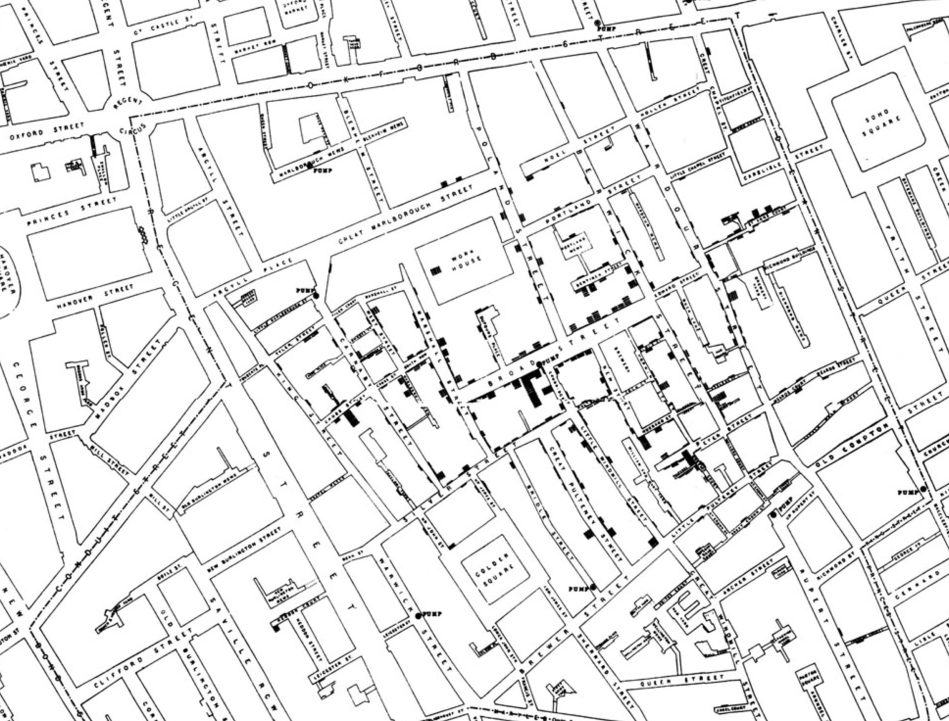
Figure 1: John Snow’s Cholera Map, 1854
The mid-1800s witnessed one of the earliest and most notorious urban pollution driven health crises, the cholera outbreak in London. Overcrowding, inadequate sanitation, and polluted drinking water converged around a single public pump on Broad Street, leading to hundreds of deaths within days. Dr. John Snow’s investigation traced the illness not to the then-dominant theory of miasma (bad air), but to Vibrio cholerae (a type of bacterium found in sewage-contaminated water) marking a major advancement in public health science. This also inherently shows the importance of public awareness of diseases. Figure 1 illustrates the map drawn by Dr. John Snow, pinpointing the cholera cases and highlighting the contaminated pump, thereby laying the foundation for modern epidemiology. This outbreak can be directly correlated with the rapid urbanisation Britain experienced during the industrial revolution. In 1801, only one-fifth of the UK population lived in towns and cities with over 10,000 inhabitants; by 1851, that figure had doubled, and including smaller towns, over half the population could be classified as urbanised. By 1901, three-quarters of the population lived in urban areas, making the UK the world’s first truly industrial and urban society. This dramatic shift from rural to urban living exemplifies how industrialisation accelerated urban growth and, in turn, exposed populations to severe health risks stemming from environmental neglect.
Furthermore, Britain's response to early pollution crises began in the mid-1800s with initiatives like the Royal Commission on Noxious Vapours (1876), which led to the legislation such as the Smoke Nuisance Abatement Act (1853) and the Alkali Act (1863) to regulate industrial emissions. Public health infrastructure also advanced after events like the Great Stink of 1858, prompting the construction of modern sewage systems designed by Sir Joseph Bazalgette, which significantly reduced cholera and typhoid rates. However, it was the Great Smog of London 1952, which caused up to 12,000 deaths. This was both an intersection between industrialisation and urbanisation, which lead to the Clean Air Act of 1956 and the rise of environmental health policy.
In details, the Clean Air Act of 1956 marked a transformative moment in environmental health policy, establishing smoke control zones and empowering local authorities to regulate emissions of smoke, grit, dust and fumes from both industrial sites and domestic furnaces. At the time, domestic coal burning accounted for nearly half of the UK’s sulphur dioxide emissions, with cities like London and Manchester suffering from dense, toxic “pea-souper” smog (British term for thick greenish-yellow smog). By mandating the use of smokeless or low-smoke fuels, such as anthracite, plasma coal and coked coal, and by incentivising households to convert heating systems, the act dramatically reduced pollution levels. Within a few years, the number of inner-London homes burning coal dropped from 87% to 15%, and the population exposed to harmful smoke fell from 450,000 to just 20,000.
Despite early progress in addressing urban pollution, the crisis persists. It has most recently been illustrated by Zimbabwe’s Harare cholera outbreak. After a prolonged 18-month epidemic that began on 12 February 2023 and spread to 62 districts, over 34,500 suspected cases and 718 deaths were recorded by June 30, 2024, when the outbreak was officially declared over by the government in accordance with WHO guidelines. However, despite the formal declaration, the issue remains. By early 2025, new cholera cases had re-emerged in at least eight districts, including Kariba and Glendale (urban settlements), underscoring the fragility of Zimbabwe’s urban health systems and infrastructure. This recurrence highlights how rapid urbanisation continues to expose millions to preventable health threats due to inadequate and overstretched water and sanitation infrastructure. While such systems are critical in preventing disease outbreaks, the water and sanitation sector remains severely underfunded. According to the Funding a Water-Secure Future report, annual spending on the water sector in developing countries is approximately USD 164.6 billion, which represents a mere 0.5% of their combined GDP. While the public sector accounts for over 91% of this spending, the private sector contributes less than 2%, indicating a heavy reliance on strained public finances. Crucially, to meet the SDGs for universal access to safe water and sanitation by 2030, global spending must increase by an additional USD 131~140 billion per year. To address these deficits, it recommends that governments not only increase financial allocations, but also improve spending efficiency, prioritise cost-effective utility operations and catalyse long-term private and international financing through public guarantees and strategic reforms.
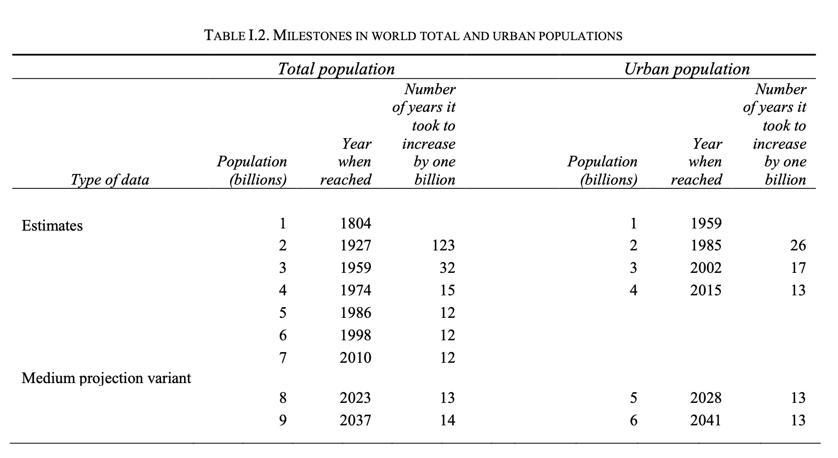Figure 2: Milestones in world total and urban populations, as estimated by the UN
In recent years, the world has reached a critical turning point in how the intersection between urbanisation, pollution, and public health is understood. The UN and the WHO have begun systematically tracking the impact of environmental degradation on human health, particularly in urban areas where these effects are most concentrated. According to the UN’s World Urbanisation Prospects (2018), the global urban population has increased from just 30% in 1950 to over 55% by 2018 and is projected to reach nearly 68% by 2050. As illustrated in Figure 2, not only has the global population been rising rapidly, but the interval between each additional billion people living in urban areas has also become increasingly shorter. From 26 years between the second and first billion to, 17 years between the third and the second, to just 13 years between the fourth and the f, 17 years between the third and the second, to just 13 years between the fourth and the four. While part of this trend can be attributed to overall population growth, the accelerating pace of urban concentration presents serious concerns for sustainable infrastructure, equitable access to resources, and the management of pollution-related health risks.
Causes and current trends of urbanisation
The United Nations identifies three primary drivers of urbanisation: natural increase, migration and reclassification. Together, these forces have accelerated urban growth globally, with especially rapid expansion observed in less developed regions.
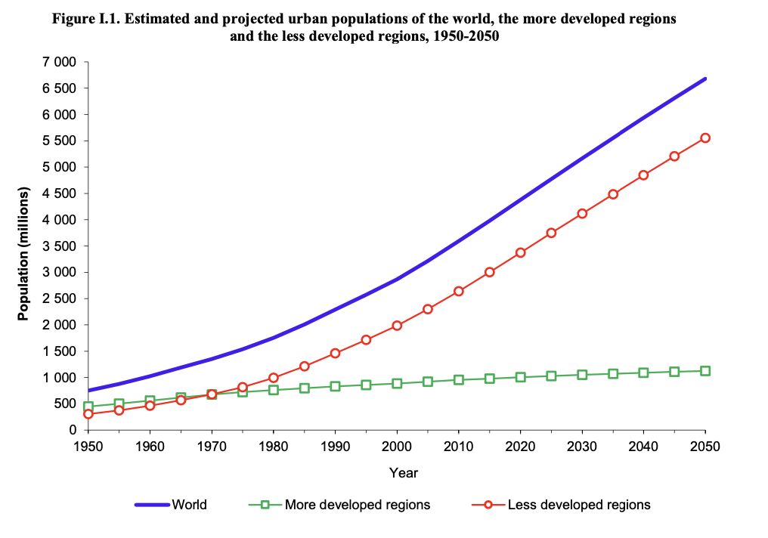Figure 3: Graph of Estimated and projected urban population of the world, the more developed regions and the less developed regions, 1950-2050, as estimated and projected by the UN
While these factors contribute to urbanisation world-wide, the most dramatic increases are occurring in less developed regions, where urban expansion often outpaces infrastructure growth and environmental regulation. This is illustrated in Figure 3, which compares the estimated and projected urban population growth from 1950 to 2050 across the world, more developed regions, and less developed regions. The graph shows that while urban populations in more developed regions have grown gradually, urban growth in less developed regions has accelerated significantly, surpassing developed regions around 1970 and projected to more than quadruple from 1950 to 2050. This demonstrates how less developed regions are now driving the global trend of urbanisation.
This shift in urbanisation patterns carries significant implications. As less developed regions become the primary centres of urban growth, the strain on already limited infrastructure and public services intensifies. Many of these cities lack robust waste management systems, reliable access to clean water and adequate health services, which makes them more vulnerable to the health risks posed by pollution. Without sufficient investment and governance capacity, rapid urban expansion may exacerbate informal settlements, increase exposure to contaminated environments and deepen existing health inequalities. If these trends continue unchecked, they could undermine efforts to achieve the SDGs.
Types of Urban pollution
Urban pollution refers to the accumulation of harmful contaminants in the air, water, and land because of human activity in densely populated city environments. It is a by-product of rapid urbanisation, industrialisation, and inadequate infrastructure/management. As cities grow in population and economic activity, the strain on natural resources and public services increases, often leading to the release of pollutants into the urban environment. United Nations estimates, ‘urban areas are responsible for 70 percent of global CO₂ emission. The consequences of urban pollution are deeply intertwined with public health, disproportionately affecting vulnerable populations such as children, the elderly, and those living in informal or underserved settlements.
Air Pollution
Air pollution is one of the most visible and hazardous forms of urban pollution. It is primarily caused by vehicle emissions, industrial discharges, burning of fossil fuels, and construction dust. In rapidly urbanising regions, poorly regulated transportation and industrial activity contribute to high concentrations of airborne pollutants such as nitrogen dioxide (NO₂), sulphur dioxide (SO₂) and fine particulate matter (PM2.5). According to the World Health Organization (WHO) more than 90% of the global population breathes polluted air.
Water Pollution
Water pollution in urban areas results from untreated sewage, industrial effluents, stormwater runoff, and poor waste disposal practices. As cities expand without adequate wastewater treatment infrastructure, contaminants are often discharged directly into rivers, lakes, or groundwater sources. This degrades aquatic ecosystems and poses significant health risks to communities relying on those sources for drinking water, bathing, and food preparation. In informal settlements or low-income urban areas, open defecation and poorly managed sanitation systems are common contributors. Outbreaks of diseases like cholera, typhoid, and hepatitis A are frequently linked to polluted water supplies, as seen in recent public health crises in cities across sub-Saharan Africa and South Asia.
Land and Solid Waste Pollution
Solid waste and land pollution are often overlooked but represent a major urban concern. Poor waste collection systems, illegal dumping, and insufficient landfill regulation lead to the accumulation of garbage in streets, vacant lots, and waterways. Plastic waste, electronic waste and hazardous chemicals often end up in open-air dumps, leaching toxins into soil and groundwater. In many developing urban areas, informal waste pickers handle large volumes of unsegregated waste without protective equipment, exposing them to health hazards.

Major Countries and Organisations Involved
United Nations Human Settlements Programme (UN-Habitat) ￼
UN-Habitat is an UN programme established in 1977 and currently operates under the motto “A better quality of life for all in an urbanising world.” It focuses on improving how cities are planned, built and managed, particularly in the context of rapid urbanisation. Through its planning frameworks and technical assistance, UN-Habitat promotes low-emission transport systems, green public spaces, and mixed-use zoning, all of which contribute are planned, built and managed, particularly in the context of rapid urbanisation. Through its planning frameworks and technical assistance, UN-Habitat promotes low-emission transport systems, green public spaces, and mixed-use zoning, all of which contribute to reducing urban pollution.
UN-Habitat's efforts are particularly significant in informal settlements, where pollution related health risks are most acute. In these underserved areas, residents often lack access to safe water, sanitation, drainage, and waste collection services, thereby increasing vulnerability to disease and toxic exposure. To address this, UN-Habitat implements slum upgrading programmes that improve physical infrastructure, reduce overcrowding, protect tenure rights, and enhance public service. As a cornerstone of this work is the Global Action inclusive, resilient and sustainable urban development. It emphasises the interconnectedness of urbanisation, environmental health, economic opportunity and social equity. It also serves as a strategic framework for governments, civil society and private actors to align their urban policies with sustainable and health-conscious practices.
World Health Organization (WHO)
The World Health Organisation (WHO) has continuously fought against urban pollution. After first issuing global air-quality guidelines in 1987, it released a substantially tightened update in 2021, noting that “the real and continued threat of air pollution to public health” demanded stronger evidence-based limits for PM_{2.5}, PM₁₀, O₃ and NO₂. Complementing these norms, WHO leads the Urban Health Initiative (UHI), which helps rapidly growing cities translate air-quality science into cross-sector polity. In Kathmandu, where pollutant concentrations average nearly five times WHO guideline levels, the UHI pilot has supported Nepal’s Department of Environment in installing the valley’s first air-quality monitoring network and training officials to conduct join health environment data analyses. In Accra, the UHI has mapped pollution sources, built inter-agency capacity, and applied WHO tools such as AirQ+ and HEAT to test transport, waste and household-energy scenarios. Modelled results show that meeting WHO air-quality guidelines could avert 1,790 premature deaths annually in Accra, while more ambitious clean-cooking and active-transport policies would save much more lives and billions of dollars in welfare costs over the coming decades. With these projects, Accra has committed to cut carbon emissions by 2050.
Developing Nations
Bangladesh
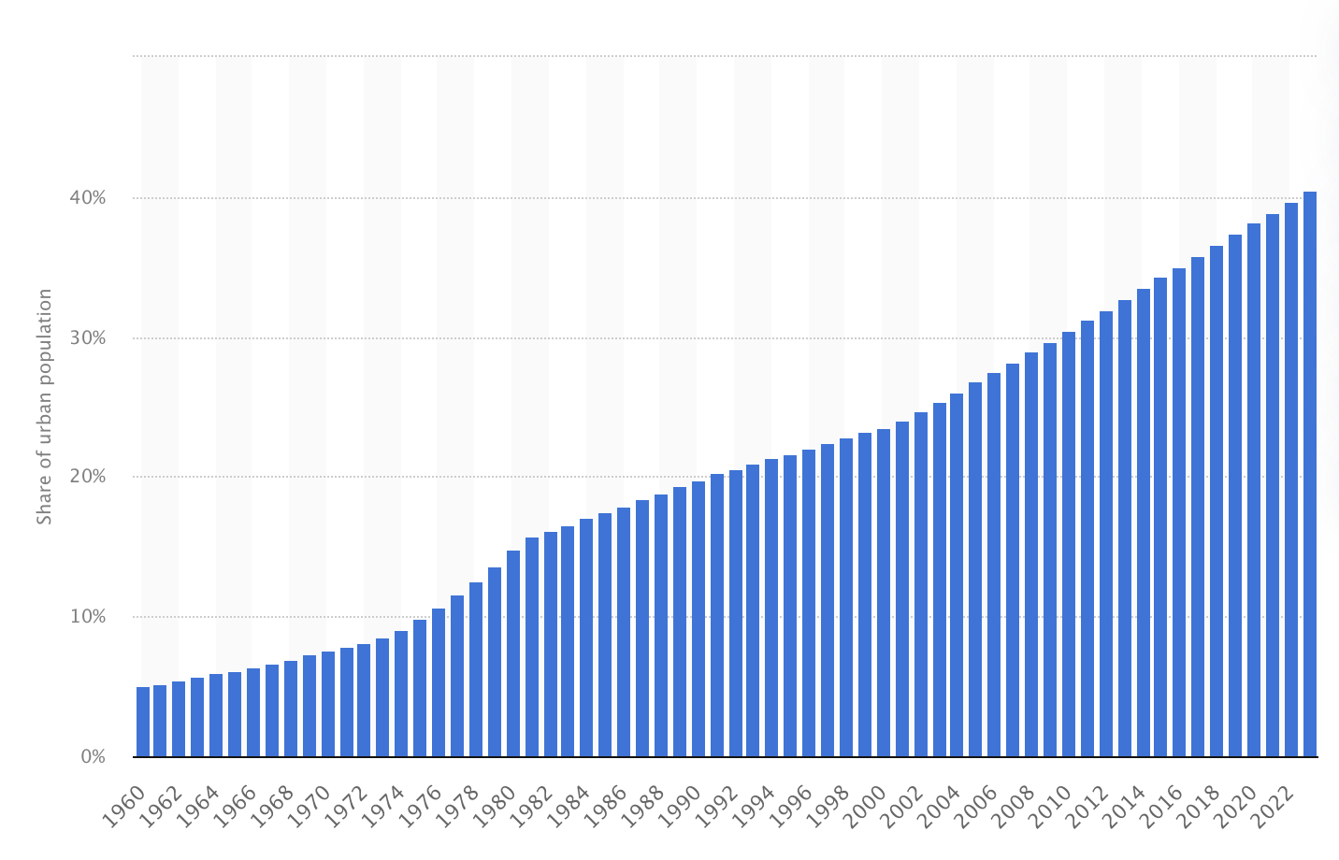Figure 4: Share of urban population in Bangladesh from 1960 to 2023, projected by Statisa in 2025/07/22
Bangladesh is experiencing rapid urbanisation, with the urban population rising from 30.46% in 2010 to 40.47% in 2023 (see Figure 4). This trend is projected to continue as rural communities migrate to urban centres in search of better economic opportunities. However, this growth has been largely unplanned, leading to severe strains on infrastructure and public services. In cities such as Dhaka and Chattogram, this expansion has resulted in overcrowded informal settlements lacking basic services. The sanitation situation remains particularly critical. As of 2015, 46% of the urban population lacked access to essential sanitation services, and only 20% of Dhaka’s residents were connected to the city’s expensive sewer network. Conditions in slums are even more dire: just 8.5% of households have access to improved sanitation, while faecal sludge is commonly discharged into open drains, fields and rivers, exacerbating the risk of disease outbreaks. These environmental hazards have translated directly into public health threats, including, as mentioned, waterborne diseases.
To address these challenges, Bangladesh has launched targeted initiatives such as the Water, Sanitation and Hygiene (WASH) programme, implemented by WaterAid and its partners. This programme operates in major urban areas including Dhaka, Chattogram and Khulna, with a dual focus on expanding WASH infrastructure and strengthening local governance mechanisms. The project has yielded notable achievements: over 150,000 people have gained access to improved sanitation, and 131,602 individuals have received access to safe drinking water. Additionally, 231,083 people have been reached through hygiene education efforts, and public sanitation facilities were used more than 16 million times, benefitting daily commuters. These outcomes reflect a significant step forward in improving public health in urban areas, though continued investment and long-term planning remain essential to meet the growing demands of Bangladesh’s urban population.
Nigeria
Nigeria is also a developing nation that is highly vulnerable to the health risks posed by rapid urbanisation-related pollution. It ranks among the most urbanised countries Africa, with over 50% of its population living in urbanised area and over 70% of its urban population living in informal settlements. This widespread lack of access to essential care exposes millions to preventable diseases and environmental hazards. As Nigeria’s urban population continues to rise, particularly in megacities like Lagos and Abuja.
Despite this urgency, government efforts have been inconsistent and under-resourced. In 2018, Nigeria declared a WASH emergency when 60 million people lacked access to basic drinking water and 80 million had no improved sanitation. A National Action Plan (NAP) launched that year sets ambitious goals for universal WASH services by 2030, but chronic underfunding, fragmented governance and weak local capacity have hindered progress.
Efforts to regulate industrial pollution have also faltered. The Niger Delta, already enduring years of oil spills, saw the launch of a USD 1 billion cleanup under the Hydrocarbon Pollution Remediation Project (HYPREP). Yet, in 2023, the UN withdrew support, citing widespread corruption, contractor incompetence and substandard environmental standards, calling the initiatives a ‘total failure'. This mirrors broader challenges in enforcing environmental regulations, from waste burning controls to building codes for traffic and cement dust.
The Nigerian case highlights the critical role of government leadership and accountability in managing the health risks caused by pollution from rapid urbanisation. While national plans and international funding exist, their success hinges on effective governance, transparency and implementation capacity. Nigeria’s experience demonstrates that without strong institutional frameworks and political will, even well-intentioned initiatives can fail. It underscores that sustainable progress depends not only on financial resources, but also on the functionality of government institutions.

Timeline of Events
Date | Description of event
17060-1840 | Heavy industrialisation – mechanised factories drive the first large scale rural-to-urban migration; coal combustion, crowding and open sewers create the archetype of the polluted industrial city.
1853 | Smoke Nuisance Abatement Act (UK) - one of the earliest laws to curb industrial emission in cities
1854 | Broad Street Cholera Outbreak (London) - demonstrates the lethal link between polluted water, overcrowding and disease laying foundations for modern epidemiology.
1858 | Great Stink of the Thames – Prompts construction of Joseph Bazalgette’s modern sewer network, improving infrastructure can slash water-borne disease in cities
1863 | Alkali Act (UK) extends control over chemical-plant emissions
1952 | Great Smog of London kills up to 12,000 – Triggers UK clean Air Act 1956 and modern ambient-air regulation
1959 | Global urban population exceeds 1 billion
1977 | UN-Habitat created - First UN body dedicated to sustainable Urban development
1980s | Orangi Pilot Project
1985-2002 | Urban population grows from 2->3 billion (26years)
2015 | 4 billion urban dwellers; interval between billions now 13 years
2016 | Habitat III – New Urban Agenda (A/RES/71/256) - set global standards for inclusive, resilient, low-pollution urban growth
2021 | WHO updates Global AQ guidelines – tightens PM2.5 annual limits.
2023 | Cholera outbreaks begins in Harare, Zimbabwe – highlights ongoing water-sanitation gaps in fast-growing less developed cities

Relevant UN Treaties and Events
- Implementation of the outcomes of the United Nations Conferences on Human Settlements and on Housing and Sustainable Urban Development and strengthening of the United Nations Human Settlement Programme (UN-Habitat), 20 December 2017 (A/RES/72/226)
- New Urban Agenda, 23 December 2016 (A/RES/71/256)

Previous Attempts to Solve the Issue
The BreatheLife Campaign
The BreatheLife Campaign is a global initiative led by the World Health Organization (WHO), the United Nations Environment Programme (UNEP), and the Climate and Clean Air Coalition (CCAC), with support from the World Bank. The campaign aims to raise awareness of the health and climate impacts of air pollution, while mobilizing cities and governments to take meaningful action. It promotes the adoption of WHO Air Quality Guidelines and encourages participating cities to reduce air pollution by implementing clean transport systems, improved waste management, sustainable energy solutions, and low-emission development strategies.
Orangi Pilot Project
The Orangi Pilot Project (OPP), based in Karachi, Pakistan, is a globally recognised model for community-led urban development, particularly in informal settlements. Initiated in the early 1980s by social scientist Dr. Akhtar Hammed Khan, the project was launched in Orangi Town, one of Karachi’s largest low-income urban settlements. OPP focused on empowering residents to construct and manage their own low-cost sanitation and drainage systems. By organising communities to finance, build and maintain simple underground sewerage systems, OPP helped improve public health outcomes by drastically reducing waterborne diseases such as diarrhoea and typhoid. The project’s participatory and decentralised approach has since been replicated in other cities across South Asia and has been cited by the UN as a successful example of bottom-up urban environmental management.

Possible Solutions
In recent years, there has been a growing recognition within the UN system that urban pollution and related health risks are disproportionately concentrated in less developed regions, where urbanisation is accelerating the fastest, but infrastructure investment often lags. Despite the commitments outlined in the New Urban Agenda and SDGs 3 and 11, international efforts have not kept pace with the scale and urgency of the crisis in low-and middle-income countries (LMICs). Delegates must consider the global trend of rapid urban expansion in the Global South and ensure that future solutions are context-specific, equity-focused and prioritise vulnerable populations.
A key area of action involves strengthening public health infrastructure in informal settlements, where one in four urban populations resides in with pollution-related health risks such as unsafe water, poor sanitation, and air contamination are most severe. While many cities have national or local urban development plans, they often fail to address the needs of residents in unplanned or informal areas. It cannot be overlooked. Integrating UN-Habitat's Global Action Plan for informal settlement should be considered. This includes investing in basic services, secure housing and inclusive waste management. With over 1 billion people currently living in slums, this number is expected to double if no targeted interventions are made.
As seen in the work of Dr. John Snow during the 1854 cholera outbreak in London, data-driven and spatially aware public health interventions can transform how cities respond to disease and pollution. His use of mapping to trace illness back to a contaminated water source laid the groundwork for modern epidemiology and serves as a powerful reminder that urban design and infrastructure must be grounded in evidence and public health priorities. In today’s context, cities must adopt similar approaches, leveraging geospatial data, pollution monitoring, and disease tracking systems to inform decision making and infrastructure development. Delegates may consider proposing the integration of real-time environmental health data into urban planning policies, ensuring that housing, sanitation, transportation and waste systems are built for disease prevention and long-term public health. This integration could be mandated at the national level through legislation, especially in high-risk urban zones or adopted as an optional framework for local governments with support from international agencies.
Regarding the implementation, international cooperation and regional partnerships are necessary to bridge the technological and financial gaps faced by less developed countries. For example, expansion of Urban health early warning system, which has been pilot tested in cities like Kathmandu under WHO’s UHI could be proposed to more at-risk urban centres. These systems enable governments and health agencies to respond quickly to acute pollution events such as smog, contaminated water or flooding related outbreaks. It should be cost-effective, scalable and could be adapted with local data inputs to protect urban residents in low-resource settings.
Another critical yet often overlooked component of addressing urban pollution and its health consequences is public education. While infrastructure and policy reforms are essential, long-term impact requires that urban residents understand the health risks associated with pollution and know how to mitigate them in their daily lives. It is important to recognise that the knowledge many people in developed or well-resourced regions take for granted, such as why clean water matters or how smog affects the lungs, is itself the result of continuous systemic education. This awareness cannot be expected of others unless it is taught, communicated and localised. Therefore, supporting community-based education campaigns, led by local health workers, educators, or NGOs, that promote awareness of issues such as air quality, safe waste disposal, and waterborne disease prevention should be considered. These efforts may include school-based environmental health curricula, mobile messaging systems, visual materials tailored to low-literacy populations, or public workshops held in informal settlements. Ultimately, public knowledge empowers behavioural change, reduces disease burden and supports broader pollution mitigation strategies.

Bibliography
A/RES/71/256: New Urban Agenda, www.un.org/en/development/desa/population/migration/generalassembly/docs/globalcompact/A_RES_71_256.pdf.
Alfred, Randy. “July 18, 1876: Royal Commissioners Wrinkle Their Noses.” Wired, Conde Nast, 18 July 2011, www.wired.com/2011/07/0718britain-royal-commission-air-pollution/.
Breathelife Campaign | Climate & Clean Air Coalition, www.ccacoalition.org/projects/breathelife-campaign.
City Planning for the Future - the Lancet Planetary Health, www.thelancet.com/journals/lanplh/article/PIIS2542-5196(25)00139-1/fulltext.
Mavhunga, Columbus. “Zimbabwe: Cholera Outbreak in Eight Districts – DW – 01/17/2025.” Dw.Com, Deutsche Welle, 17 Jan. 2025, www.dw.com/en/zimbabwe-cholera-outbreak-in-al-least-eight-districts/a-71333093.
O’Neill, Aaron. “Share of Urban Population Bangladesh.” Statista, www.statista.com/statistics/455782/urbanization-in.
ProfilePage, et al. “Nigerian Agency ‘failed Completely’ to Clean up Oil Damage despite Funding, Leaked Files Say.” AP News, AP News, 7 Jan. 2025, apnews.com/article/nigeria-niger-delta-oil-spill-cleanup-hyprep-8c7533ad31d1aad5c0e3933a41891579
The Great Stink - A Victorian Solution to the Problem of London’s Waste | Historic England, historicengland.org.uk/images-books/archive/collections/photographs/the-great-stink/.
Urbanisation in Bangladesh: Challenges And ..., asef.org/wp-content/uploads/2021/11/ASEFSU23-Background-Paper_Sustainable-Urbanisation-in-Bangladesh-Dhaka.pdf
“9 out of 10 People Worldwide Breathe Polluted Air, but More Countries Are Taking Action.” World Health Organization, World Health Organization, www.who.int/news/item/02-05-2018-9-out-of-10-people-worldwide-breathe-polluted-air-but-more-countries-are-taking-action.
“Clean Air Act 1956.” Policy Navigator, navigator.health.org.uk/theme/clean-air-act-1956#:~:text=Legislation%20and%20impact,these%20materials%20could%20be%20banned.
“Document Viewer.” United Nations, United Nations, docs.un.org/en/A/RES/72/226
“Europe’s Air Quality Status 2024.” European Environment Agency, 30 July 2024, www.eea.europa.eu/publications/europes-air-quality-status-2024.
“Funding a Water-Secure Future: An Assessment of Public Spending Key Messages.” World Bank, World Bank Group, 18 Dec. 2024, www.worldbank.org/en/topic/water/publication/funding-a-water-secure-future#:~:text=Countries%20need%20to%20increase%20their,execution%20rate%20is%20about%2072%25.
“Global Action Plan” Unhabitat, United Nations, unhabitat.org/sites/default/files/2023/06/gap_presentation_as_handout-un-habitat_assembly-pdf.pdf
“Impact of the Industrial Revolution.” Encyclopædia Britannica, Encyclopædia Britannica, inc., 24 June 2025, www.britannica.com/topic/urbanization/Impact-of-the-Industrial-Revolution.
“Nigeria: Ensuring Water, Sanitation and Hygiene for All.” World Bank, World Bank Group, 26 May 2021, www.worldbank.org/en/news/feature/2021/05/26/nigeria-ensuring-water-sanitation-and-hygiene-for-all.
“Nigeria: The Human Cost of a Megacity.” Amnesty International UK, www.amnesty.org.uk/lagos-nigeria-human-cost-megacity.
“Photography.” National Geographic, www.nationalgeographic.com/photography/.
“Pilot Projects: Accra and Kathmandu.” World Health Organization, World Health Organization, www.who.int/initiatives/urban-health-initiative/pilot-projects.
“Subscribe with US.” Orangi Pilot Project - Research and Training Institute, www.opp.org.pk/.
“The 1956 Clean Air Act - Understanding the Impact.” Smokeless Coals, 3 Aug. 2023, smokelesscoals.co.uk/learn-about-the-uks-1956-clean-air-act/
“Urban Health Initiative.” World Health Organization, World Health Organization, www.who.int/initiatives/urban-health-initiative.
“Urbanization.” CEB, unsceb.org/topics/urbanization#:~:text=Urbanization%20is%20one%20of%20the,economic%20growth%2C%20productivity%20and%20development.
“Water, Sanitation and Hygiene for Urban Communities” WaterAid, washmatters.wateraid.org/projects/water-sanitation-hygiene-urban-populations-bangladesh
“What Are the Who Air Quality Guidelines?” World Health Organization, World Health Organization, www.who.int/news-room/feature-stories/detail/what-are-the-who-air-quality-guidelines.
“What Is Urbanisation?: UN-HABITAT Regional Office for Asia and the Pacific (Fukuoka).” UN, fukuoka.unhabitat.org/en/urbanisation/.
“World Urbanization Prospects.” United Nations, United Nations, population.un.org/wup/assets/WUP2018-Report.pdf.
“Zimbabwe Declares Cholera Outbreak Over.” World Health Organization, World Health Organization, www.afro.who.int/countries/zimbabwe/news/zimbabwe-declares-cholera-outbreak-over#:~:text=Harare%20%2D%20The%20Government%20of%20Zimbabwe,began%20on%2012%20February%202023.

