Forum: World Health Assembly (WHA)
Issue: Developing measures to reduce tobacco and nicotine consumption and their health impacts
Student Officer: Maria Figueiredo
Position: Deputy President

Introduction
Today, the use of nicotine and tobacco have been more common than ever. With the rapid production of E- Cigarettes, and vapes, what could this do to the upcoming generations? These smoking-cessation aids—devices, gum, patches—are easy for youth to obtain and, though perceived safer than cigarettes, are themselves addictive. Smoking devices cause lung cancers like bronchiolitis obliterans and bronchogenic carcinoma, it can also cause mouth and teeth cancers such as: squamous cell carcinoma. . A more variated group of cancers it causes is throat cancers consisting of: Laryngeal cancer, Pharyngeal cancer, Oropharyngeal cancer, Hypopharyngeal cancer, and Tonsil cancer. Nicotine patches can accelerate heart rates, and have a significant rise in blood pressure, red skin and irritation, can induce insomnia, and vivid dreaming, nausea and vomiting.
Contemporary adolescents frequently initiate vaping in response to pronounced social pressures; the practice is widely construed as emblematic of “coolness,” thereby perpetuating a cycle of peer influence. Many teenagers want to do all they can to be relevant and popular. It can be as simple as following clothing trends and can take a darker turn at doing things critical to their health. Vaping, having high levels of nicotine provides an easy way to dependence and addiction, which makes it harder for people to repel from after using them for a certain period. This is what is well known as self-determination theory.
Self Determination Theory (SDT) serves as a comprehensive framework for examining human motivation and personality. SDT provides a meta- theory to structure motivational research, a formal theory that outlines intrinsic and various extrinsic motivations, and an explanation of how these motivations influence cognitive and social development, as well as individual differences. Importantly, SDT also examines how social and cultural factors can either support or undermine people’s sense of autonomy and initiative, as well as their overall well-being and performance quality.
SDT also emphasizes the importance of three psychological needs: autonomy, competence and relatedness. When these needs are met, individuals are more likely to feel motivated and less pressured. Conversely, when these needs are thwarted, individuals may experience increased pressure and decreased well-being.
According to ScienceDirect, when youth feel in control of their own actions which is directly connected to the Intrinsic Motivation, it is less likely for them to want to stop what they’ve taken decision upon. This will result in them not wanting help and growing to become long time smokers.
In conclusion, SDT provides a nuanced understanding of how different types of motivation and the fulfilment of psychological needs influence the experience of pressure. By recognizing the interplay between intrinsic and extrinsic motivations and the importance of autonomy, competence and relatedness. This theory greatly supports the rise of people who decide to vape and smoke.

Definition of Key Terms
Substance dependence/ addiction
Substance dependence refers to the psychological or physical reliance on a substance and can cause withdrawal symptoms when substance is not in use.
Social pressure
When influences around one push them to do something, could be a friend or family, social media, news, etc.
Self-Determination theory (SDT)
A theory that explains how social and environmental factors determine human motivation, well-being and behavior by emphasizing the importance of meeting basic psychological needs for autonomy, competence, and relatedness.
Intrinsic Motivation
Intrinsic Motivation is when one decides to do things for the personal pleasure it brings them and helps fulfill themselves.
Extrinsic Motivation
Extrinsic motivation is when one is compelled to do a certain thing due to the pressure they receive from others. This could be from friends, media, or culture.
TAPS (Tobacco Advertising, promotion and sponsoring)
TAPS refers to the marketing tactics used by tobacco companies to promote their products.

Background Information
Tobacco/ Cigarettes
Tobacco has been largely used in the Americas for approximately 8000 years. Around 2000 years ago, tobacco was being used in chewing and smoking properties for religious or cultural celebrations. The first accounted European to discover smoking was Christopher Columbus the year is unknown. Tobacco began being cultivated in Santo Domingo by 1531 and by 1600 it was spread to England and used as a Monetary Standard and continued for the coming century. An anonymous English author released an essay on how cancer could be caused by soot and tobacco can have the same effects. This essay was released in 1602. In the 1800s the first cigarette producing machine was made and it produced about 200 cigarettes per minute (todays machines produce around 9000). The first ever medical reports regarding the connection of tobacco causing lung cancer were released in the 1920s, but newspapers often refused to include them due to the fear of harming big tobacco companies’ reputation. Smoking spiked during the two world wars since it was given to soldiers for free as a moral boosting practice.
Vapes/ E-smoking devices
Ever since E-cigarettes were introduced in 2003, the popularity and use quickly rose and till this day is still rising. The first account of E-cigarette users was in 2011 where there were around 7 million adult users worldwide, and in 2020 it increased to 68 million. The popularity of E-cigarettes comes primarily from the propaganda of it being “healthier” and “less harmful” than cigarettes. This causes people who have dependence on tobacco to believe the vapor will be less harmful than smoke. E- cigarettes are also a lot more accessible to younger people due to how much shop keepers will not bat an eye at children wanting to buy substances being underage. This is also caused by wanting to receive as much money as they can, and it doesn’t matter who gives it to them.
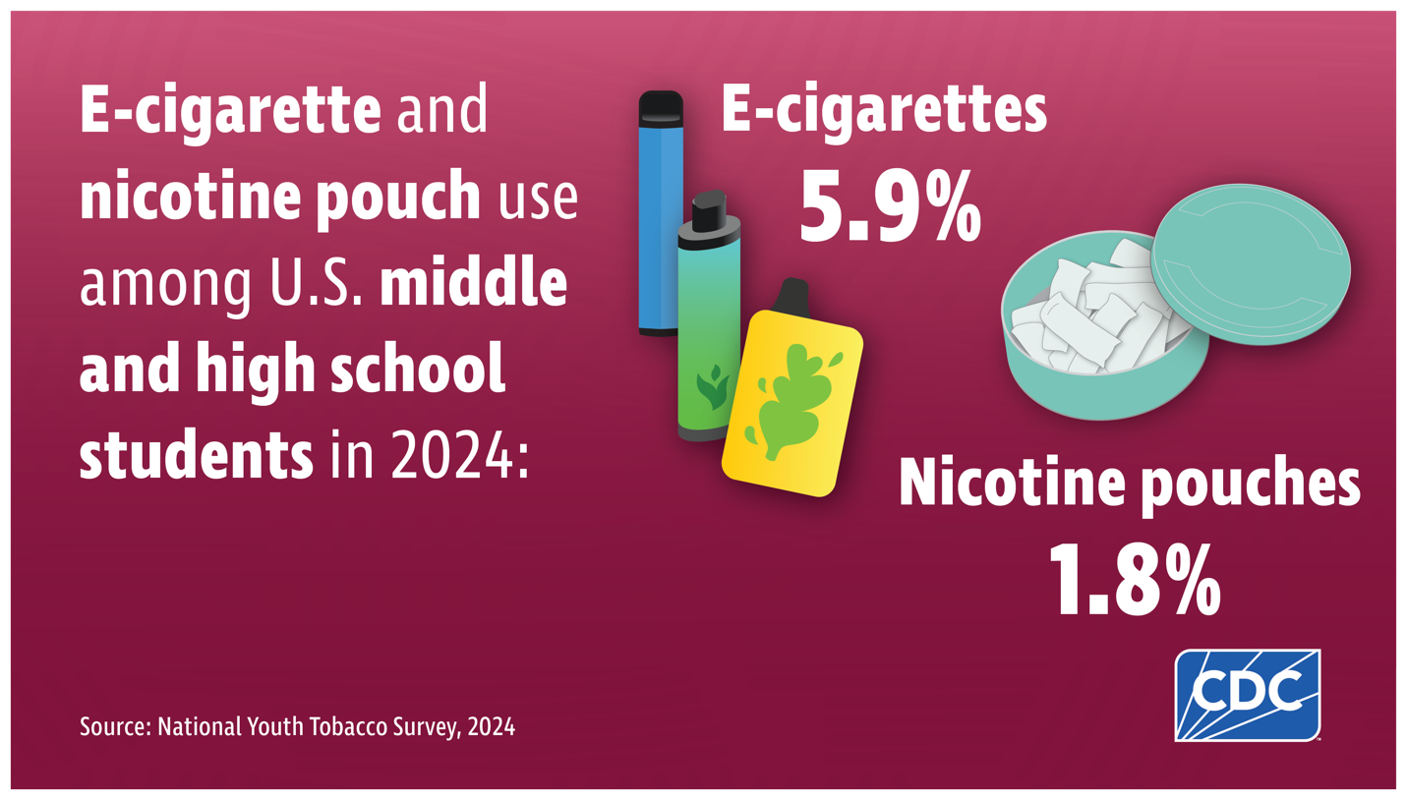
Caption 1: Current use of e-cigarettes and nicotine pouches among U.S. middle and high school students in 2024.
1.63 million middle and high school students use E-cigarettes. More specifically, 410,000 middle school students and 1.21 million high schoolers. The most popular brands used are Elf Bar, Breeze and Mr. Fog.
In 2021, and average 7 in 10 middle and high school students said they had been exposed to the advertisement of E-cigarettes. Many seeing these advertisements technologically on TV and social media. Vaping, different from regular smoking, can have different Flavors in which people will enjoy more. It also makes it easier to hide it from parents and care takers as the smell won’t be as noticeable.
Advertising Methods
Although not precisely calculated, it is believed that the tobacco industry’s spend tens of billions of dollars every year only on advertising tobacco products in the USA alone. And spends more than 10 billion USD annually on TAPS activities. For a product that kills half its users, advertising needs to be extremely convincing which is why tobacco companies are known for being some of the most manipulative ways of advertising a product. Although TAPS activities are supposed to appeal to all groups and mostly among current smokers, specific efforts are made to make non- smokers start smoking, and so the advertisement will target youth, which is the ages most people will begin smoking and women, who are less likely to smoke compared to men. Users will be very loyal to their chosen smoking brand, so choosing the right one is very important for new smokers, which as a result gifts tobacco companies with life-long customers. Exposure to TAPS at young ages also causes youth to have more of a positive image on smoking products which will contribute to their want of smoking in the future.
Women who didn’t have such a huge population of smokers, were their main targets due to the rise of financial independence women started having in the world, and it was estimated to increase a huge amount from 2005-2025 (which it has). Many brands are also changing their appeal to women and in South Korea, these strategies increased the number of female users from 1.3% to 13% between 1988 and 1998.
Tobacco use is more stable in developed countries but is spreading rapidly to countries that are rising in economy. Which means tobacco companies are racing to expand TAPS activates overseas to many countries.
In Guinea, companies will hire attractive young woman to promote cigarettes in various places. This mostly helps attract men and will expand promotion rapidly. This isn’t a tactic only in Guinea.
In Indonesia and Senegal, many public basketball courts are painted with the brands of cigarettes, public basketball courts are more commonly used by teenagers. In Indonesia, many popular singers have performed concerts under the sponsorship of cigarette brands. Tobacco advertisement continue to be big in bars, cafes and nightclubs in al WHA regions.
In Brazil, a popular gaming machine spaced in many places has players capture a Marlboro logo to win prizes and will additionally get their email addresses to send promotional material to players.

Major Countries and Organizations Involved
In 2003 the first WHA framework was drafted to reduce the use of tobacco for younger generations and over 183 countries have participated in this treaty, with major ones: United Kingdom, Portugal, France, Canada, Australia and Mexico. The treaty states “Parties to this convention are determined to give priority to their right to protect public health.” Becoming a global trend setter. The treaties’ core demands were price and tax measures to reduce the demand for tobacco, and on-price measures to reduce the demand for tobacco. The WHA FCTC opened for signatures in 2003 in Geneva, making it one of the most signed treaties of UN history.

Date | Description of event
6000 BCE | Tobacco begins being used in the Americas for chewing and smoking, mainly for religious or cultural celebrations.
1500s | Christopher Columbus is the first European to discover smoking tobacco.
1531 | Tobacco is being cultivated in Santo Domingo
1600 | Tobacco reaches England and is used as a monetary standard.
1602 | An anonymous English author publishes an essay suggesting cancer could be cause by soot and tobacco.
1800s | The first cigarette machines were made, producing about 200 cigarettes per minute (todays’ machines produce about 9000 per minute)
1920s | First medical reports link tobacco to lung cancer, though widely underreported due to tobacco company influence.
WW1 & WW2 (1914-1945) | Smoking spikes as cigarettes are given to soldiers for free as a morale booster.
2003 | Introduction of Vapes
2011 | Number of E-cigarette users go up to 7 million users worldwide
2020 | 68 million users worldwide.

Previous Attempts to Solve the Issue
TAPS reduction
In 2013, the WHA enforced bans on tobacco sponsorship and advertising, and promotion. The WHA took concentrated matters and in May 1996 resolution 49.17 was passed to control measures for Tobacco use. From the tobacco industry’s point of view, they should normalize using tobacco and higher the demands of products. The WHA believes that meaningful tobacco use must eliminate all forms of TAPS. This goals demand is so high that it has a time limit of when all member states should implement this. This goal prohibits all TAPS activities that promote tobacco use that are misleading such as using the words “light” or “mild” to describe the use of products. Ensure that health warnings are appropriately added to advertisements. Limit the use of direct or indirect incentives that encourage the purchase of tobacco products. Additionally, article 13 called for all member states to create a new treaty to address cross-border TAPS activities.
Nicotine Replacement Therapy
Nicotine replacement therapy was introduced in the early 1980s. NRT is a way to consume nicotine in different ways to help combat the addiction to tobacco, and smoking. Users will receive nicotine patches that are applied to the skin, chewing gums, inhalers, nose sprays, and lozenges. NRT has a success rate of 50-70%.
A few countries around the world also have stronger laws against people who sell illegal products to youth and will include graphic imaging on packaging.
Brazil’s cigarette solution
The article by Maia et al. (p.730) shows attempts from Brazil to reduce cigarette consumption from 2006-2019. The article shows that Brazil’s policies have been among the most successful in the Americas and worldwide. Brazil signed the WHA treaty in 2006, and its main goals were, reducing advertising and promotion of and raising taxes on cigarettes, employing large pictorial labels on cigarette packs, and restricting the use of cigarettes in public spaces.
According to the WHA in 2018, Brazil’s adult users was 11.8%, compared to the United States which is 16.3%. Until today, the use of graphic imaging in cigarettes is very prevalent, and advertisement is close to none in major cities such as, Brasilia and São Paulo.

Possible Solutions
Schools should implement assistance when it comes to this. Public schools specifically should have more rigorous rules when it comes to students and the use of vapes. While providing a more helpful group of therapists to assist students in quitting. This would help students who especially don’t come from a wealthy background to get help for free.
An organization can be made to distribute NRT products to anyone in need, by them registering on a website. This will help underprivileged citizens to receive what they need without having to pay a lot of money. This solution will help greatly to decrease the amount of people who are currently smoking, preventing further influence on others. The WHA committee should further discuss this idea considering the fact that it is hard for individuals to access NRT products and maybe don’t have the means or access to these products.

Bibliography
“Current Cigarette Smoking Among Adults in the United States.” Smoking and Tobacco Use, 17 Sept. 2024, www.cdc.gov/tobacco/php/data-statistics/adult-data-cigarettes/index.html.
Wikipedia contributors. “Electronic Cigarette.” Wikipedia, 7 July 2025, en.wikipedia.org/wiki/Electronic_cigarette#Use.
Theory – selfdeterminationtheory.org. selfdeterminationtheory.org/theory.
“Vaping and Quitting.” Smoking and Tobacco Use, 15 May 2024, www.cdc.gov/tobacco/e-cigarettes/quitting.html.
De Jesus, Maria Cristina Pinto, et al. “Understanding Unsuccessful Attempts to Quit Smoking: A Social Phenomenology Approach.” Revista Da Escola De Enfermagem Da USP, vol. 50, no. 1, Feb. 2016, pp. 71–78. https://doi.org/10.1590/s0080-623420160000100010.
World Health Organization. WHO Report on the Global Tobacco Epidemic, 2013: enforcing bans on tobacco advertising, promotion and sponsorship [Internet]. Geneva; 2013 [cited 2015 Apr 13]. Available from: Available from: http://apps.who.int/iris/bitstream/10665/85380/1/9789241505871_eng.pdf
World Health Organization: WHO. Tobacco. 25 June 2025, www.who.int/news-room/fact-sheets/detail/tobacco#:~:text=To%20address%20the%20tobacco%20epidemic,costs%20from%20averted%20healthcare%20expenditure.
“E-Cigarette Use Among Youth.” Smoking and Tobacco Use, 17 Oct. 2024, www.cdc.gov/tobacco/e-cigarettes/youth.html.
Nsw, Cancer Council. “A Brief History of Smoking.” Cancer Council NSW, 29 Mar. 2023, www.cancercouncil.com.au/news/a-brief-history-of-smoking.
Brown, J. R., and J. L. Thornton. “Percivall Pott (1714-1788) and Chimney Sweepers’ Cancer of the Scrotum.” Occupational and Environmental Medicine, vol. 14, no. 1, Jan. 1957, pp. 68–70. https://doi.org/10.1136/oem.14.1.68.
Centers for Disease Control and Prevention (US). “Introduction, Conclusions, and Historical Background Relative to E-Cigarettes.” E-Cigarette Use Among Youth and Young Adults - NCBI Bookshelf, 2016, www.ncbi.nlm.nih.gov/books/NBK538684/#.
Brasil. Ministério da Saúde; Secretaria de Vigilância em Saúde. Vigitel Brasil 2011: vigilância de fatores de risco e proteção para doenças crônicas por inquérito telefônico [Internet]. Brasília; 2012 [citado 2015 abr. 13]. Disponível em: Disponível em: http://bvsms.saude.gov.br/bvs/publicacoes/vigitel_brasil_2011_fatores_risco_doencas_cronicas.pdf
Silva ST, Martins MC, Faria FR, Cotta RMM. Combating smoking in Brazil: the strategic importance of government actions. Ciênc Saúde Coletiva. 2014;19(2):539-52.
Minist�Rio Da Sa�De. bvsms.saude.gov.br/bvs/saudelegis/gm/2013/prt0571_05_04_2013.html.
TAPS Policy Implementation | Vital Strategies Tobacco Control Implementation Hub. www.tcimplementationhub.org/policy-areas/taps-policy-implementation

Appendix
- https://pmc.ncbi.nlm.nih.gov/articles/PMC1037746/
- https://www.cdc.gov/tobacco/secondhand-smoke/health.html
- https://acsjournals.onlinelibrary.wiley.com/doi/full/10.3322/caac.21413
- https://tobaccocontrol.bmj.com/content/21/2/191.short
- https://journals.sagepub.com/doi/abs/10.1177/146642400312300315

